## **Unit 2 Lab: Your Kali Machine**

### **Overview**

In this lab, you will be creating a Linux Virtual Machine using the Azure portal and learning commands to navigate around it.

#### **Required Features**

A simple version of the virtual machine and web server with the core features implemented will be configured as seen in the images below:

* **A Kali Linux virtual machine (logged in remotely via ssh)  
  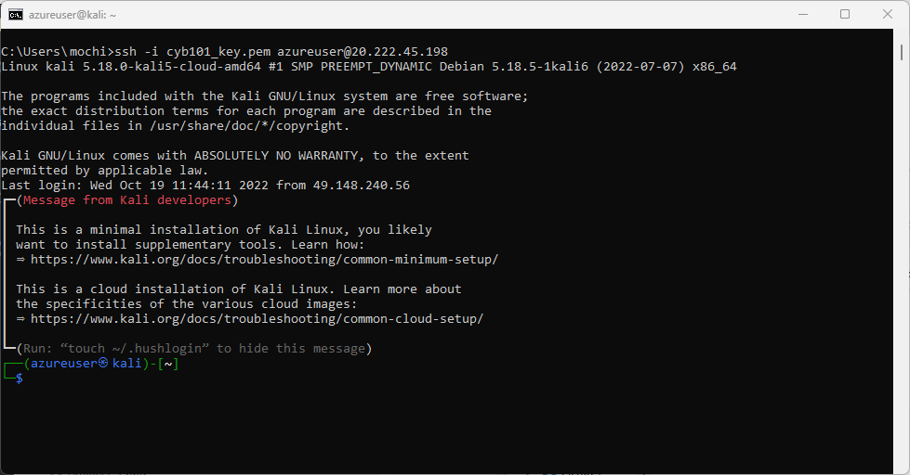**
* **Desktop access to the Kali machine using RDP  
  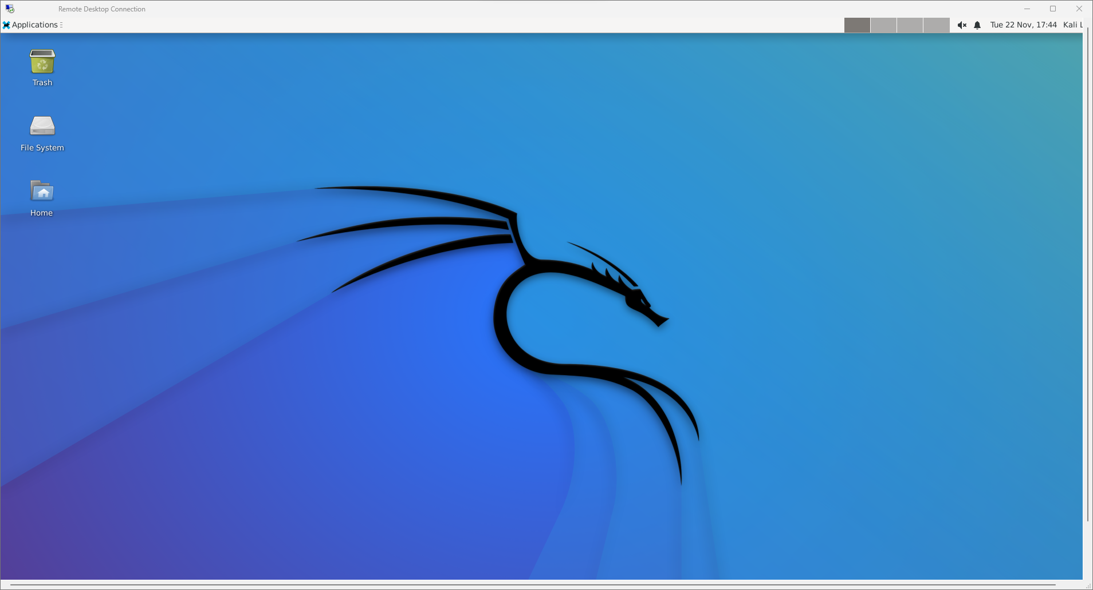**

#### **Stretch Features**

* **Install and play Super Mario in the VM's web browser!  
  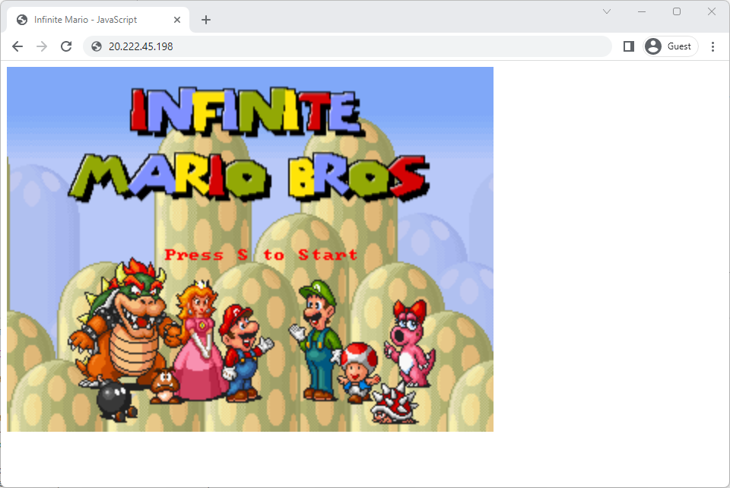**

### **🎯 Goals**

By the end of this lab you will be able to...

* Create an Azure Account
* Create a Kali Linux virtual machine in the Azure Portal
* Establish an SSH connection with the virtual machine
* Gain familiarity with and navigate around the Linux command line

### **Resources**

* [Azure account with a free subscription](https://azure.microsoft.com/en-us/free/students/)
* [Create a Linux virtual machine in the Azure Portal](https://www.kali.org/docs/cloud/azure/)

## **Lab Instructions**

### **Required Features**

#### **Step 0: Azure Account (LAB PREREQUISITE)**

* To complete this lab, you **must** have an Azure account that allows resource creation in the 🔗 [**Azure portal**](https://portal.azure.com/#home).
* If you haven't already, click here to register for a 🔗 [**free Azure account for Students**](https://azure.microsoft.com/en-us/free/students/). Azure offers free accounts to students with .edu emails.

🛑 Don't proceed until you've verified you have an Azure Account with at least one [**subscription**](https://learn.microsoft.com/en-us/azure/azure-portal/get-subscription-tenant-id#find-your-azure-subscription).

#### **Step 1: Creating a Kali Virtual Machine**

1. Sign in to the [Azure portal](https://portal.azure.com/) using the account you've just created with the free subscription.
2. From the [Azure Homepage](https://portal.azure.com/#home), search for *"virtual machines"*.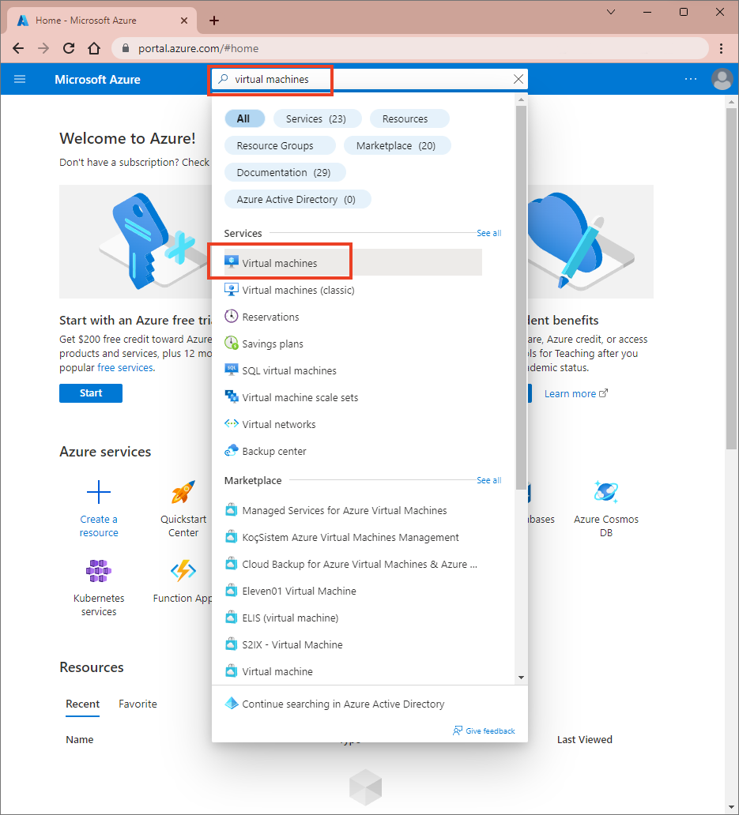
3. On the search results, select **Virtual machines** under **Services**.
4. From "**Virtual machines**" page, click "**+ Create**" and select "**Azure virtual machine**".  
   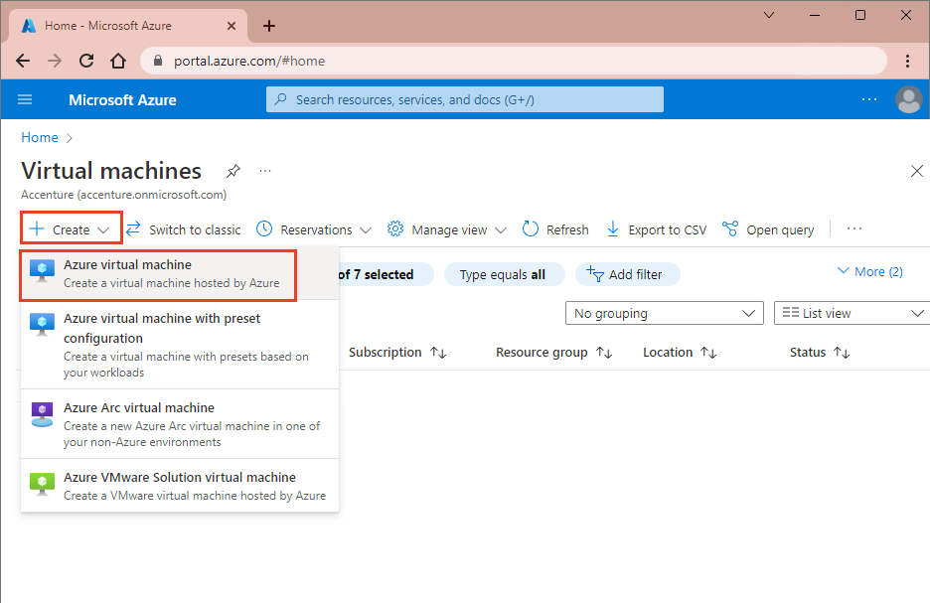
5. In the "**Create a virtual machine**" page, the **Basics** tab will be shown by default (in case it's not, click on the **Basics** tab in the navigation). Under **Project details**, input the following details:
   * Select the appropriate **Subscription**. With a student account, this will display as Azure for Students.
   * Choose **Create new** from the **Resource group**. Enter any name that you like for your Resource group!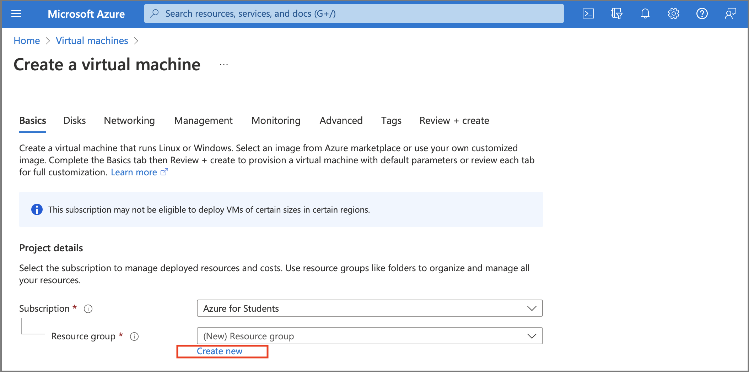  
     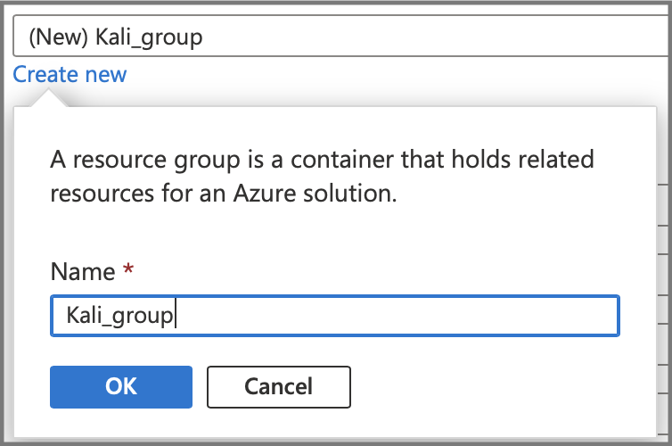
6. Under **Instance details** section:
   * **Virtual machine name**: The virtual machine name cannot be changed after the VM is created. This VM is going to be your faithful companion throughout this course -- give it a cool handle!
   * **Region**: Select (US) East US (the Kali VM we'll need will not be available under other regions).
   * **Availability options**: Select Availability zone.
   * **Availability zone**: Select Zones 1.
   * **Security type**: Leave the Security Type as Standard.
   * **Image**: Choose Kali Linux Image Kali 2022.3 (kali-rolling) - x64 Gen 2.
     + If you don't see it in the dropdown list, click on "See all images" link underneath the dropdown menu. In the "Search the Marketplace" search bar at the top, type Kali Linux. In the search results, click on the Kali 2022.3 kali-rolling - x64 Gen 2 version, as shown below:
   * 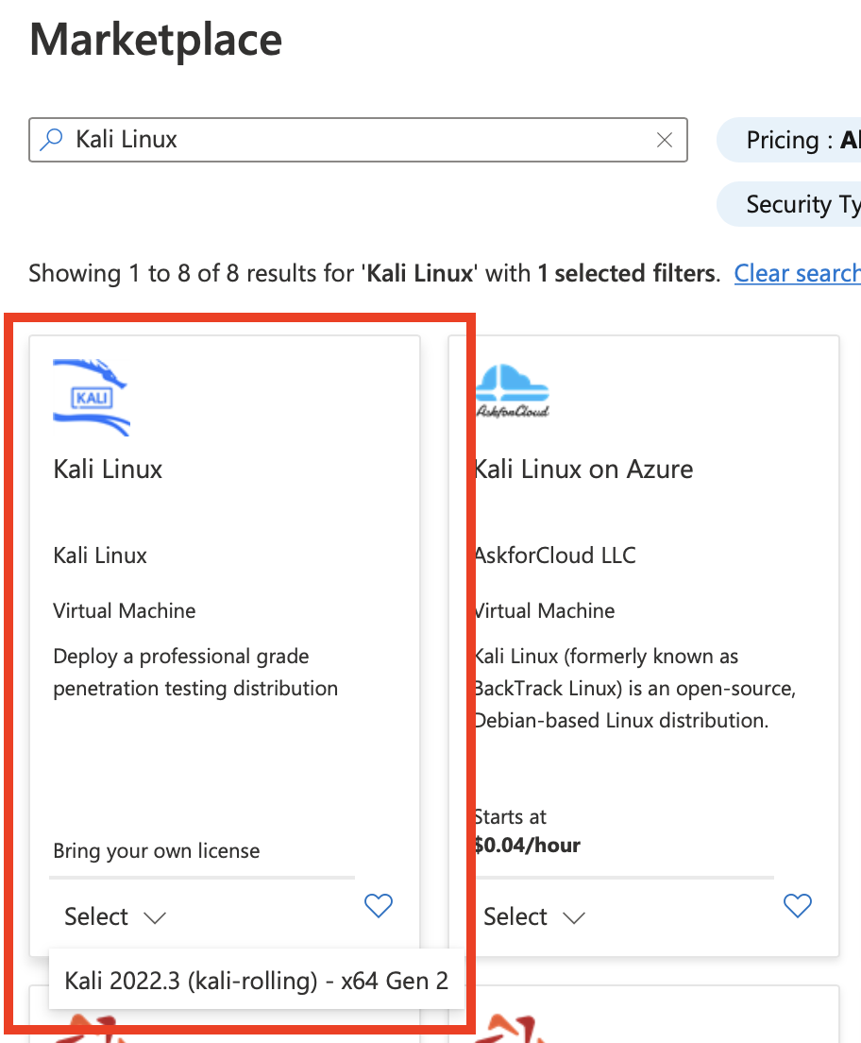
   * Finally, leave the other fields at their default settings.
     + **VM architecture**: Leave as x64
     + **Run with Azure Spot discount**: Leave this box unselected
     + For the VM Size, select Standard_B1ms - 1 vcpu, 2 GiB memory.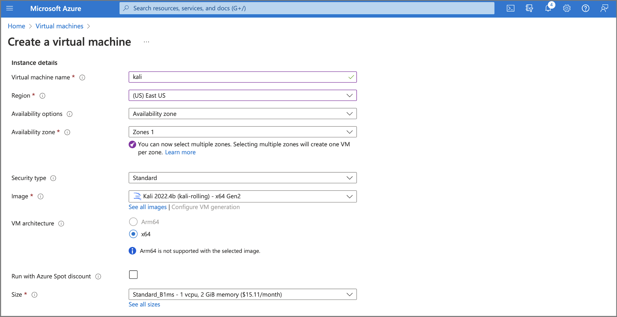
   * ⚠️ If you happen to see the error below, check that the Region for the Virtual Machine is set to (US) East US: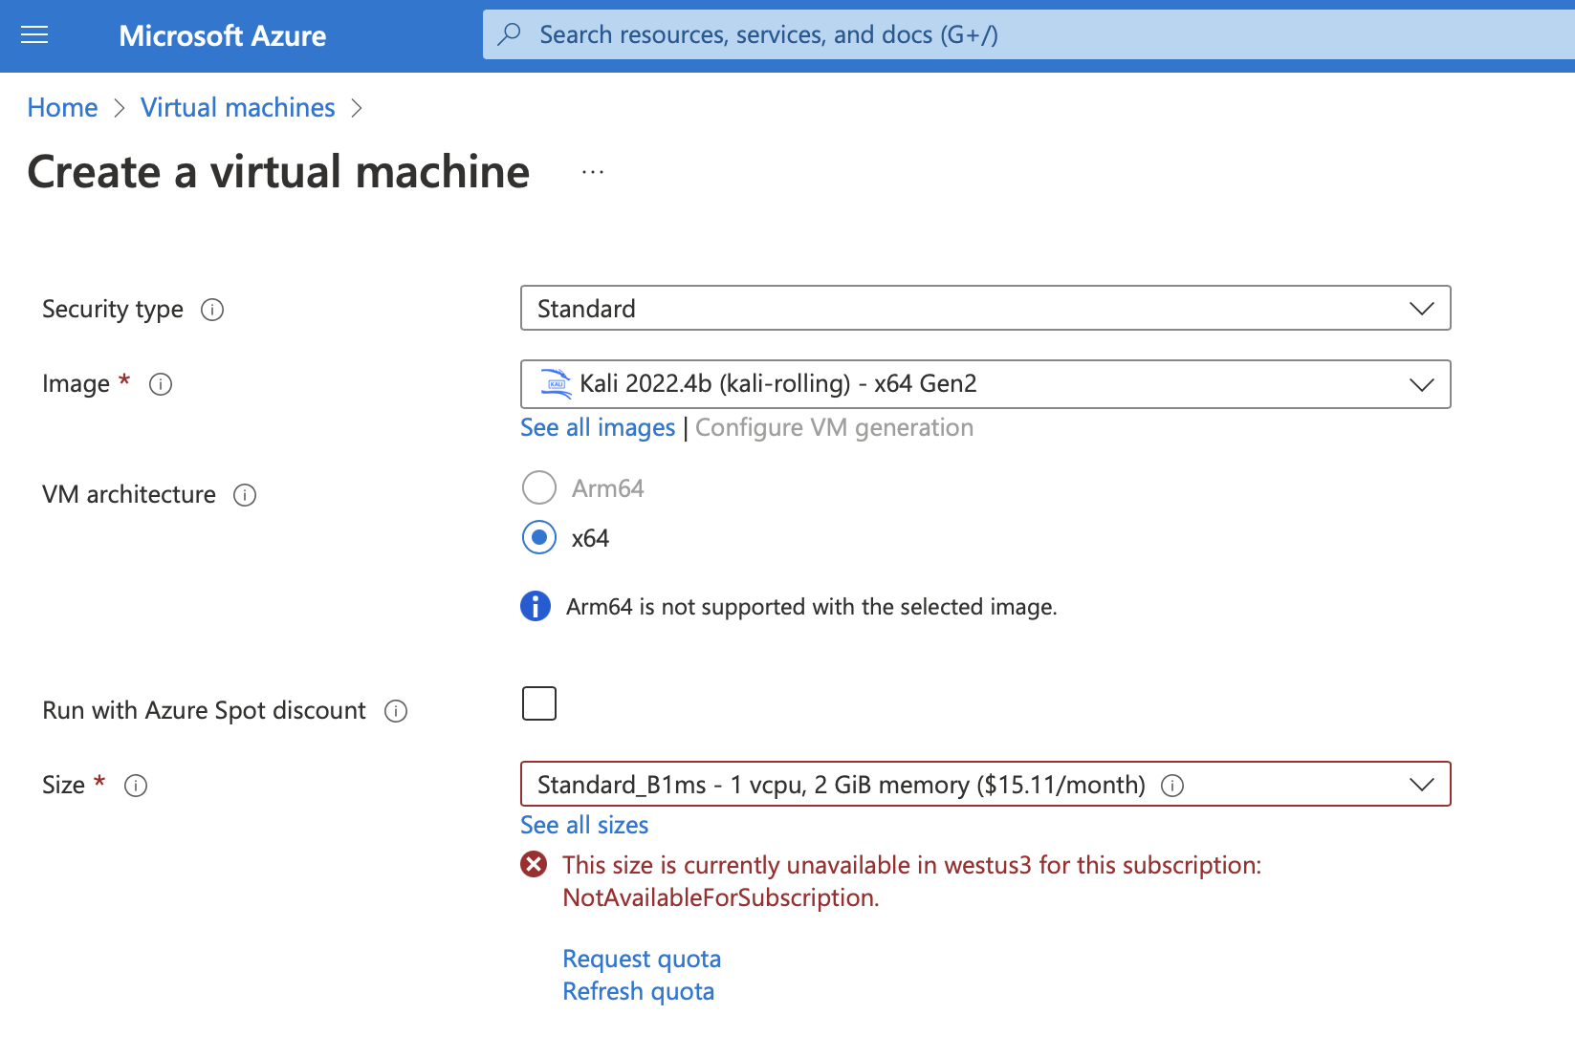
7. Under **Administrator account** section:
   * **Authentication type**: Select SSH public key.
   * **Username**: Enter any name that you like!
   * **SSH public key source**: Leave the default option, Generate new key pair.
   * **Key pair name**: Enter any name that you like!
8. 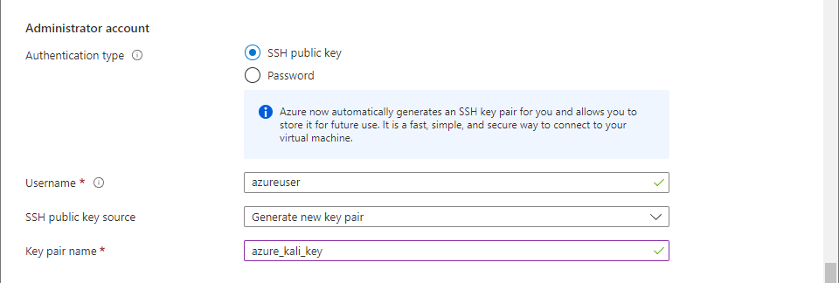
9. Under **Inbound port rules** section:
   * **Public inbound ports**: Choose Allow selected ports.
   * **Selected inbound ports**: Select SSH (22) from the drop-down.
10. 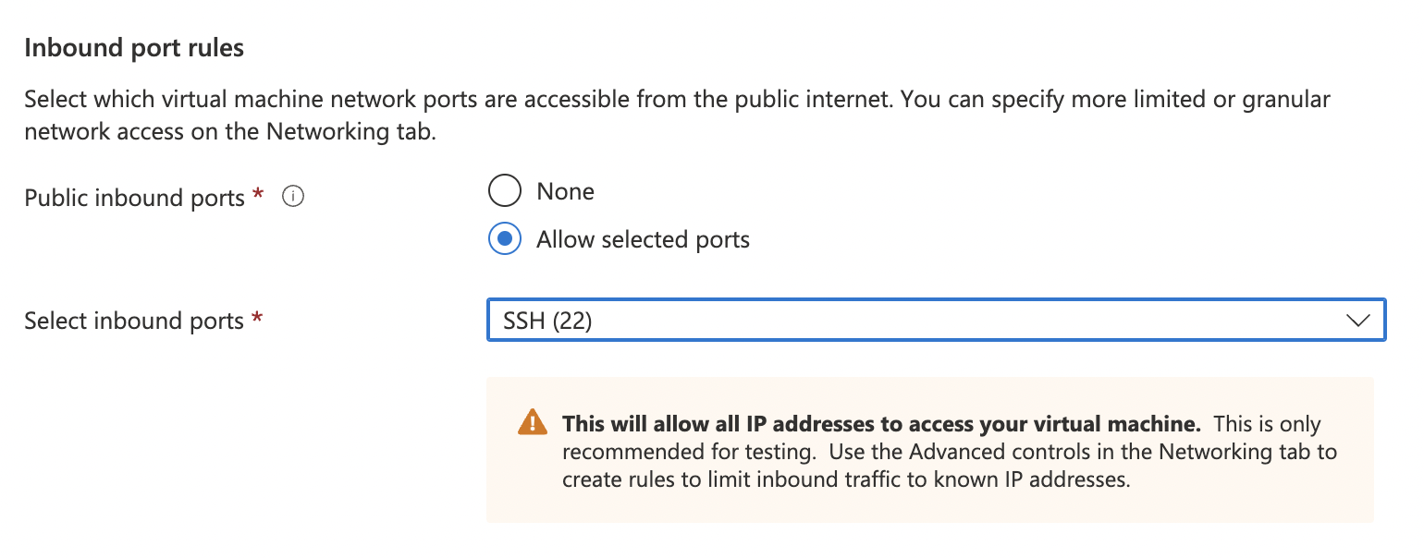
11. Click **Next: Disks**. In the **Disks** tab, under **Data disks**, click **Create and attach a new disk**. You can keep the rest of the default values as shown. Check the box that says Delete disk with VM, then click **OK**.  
    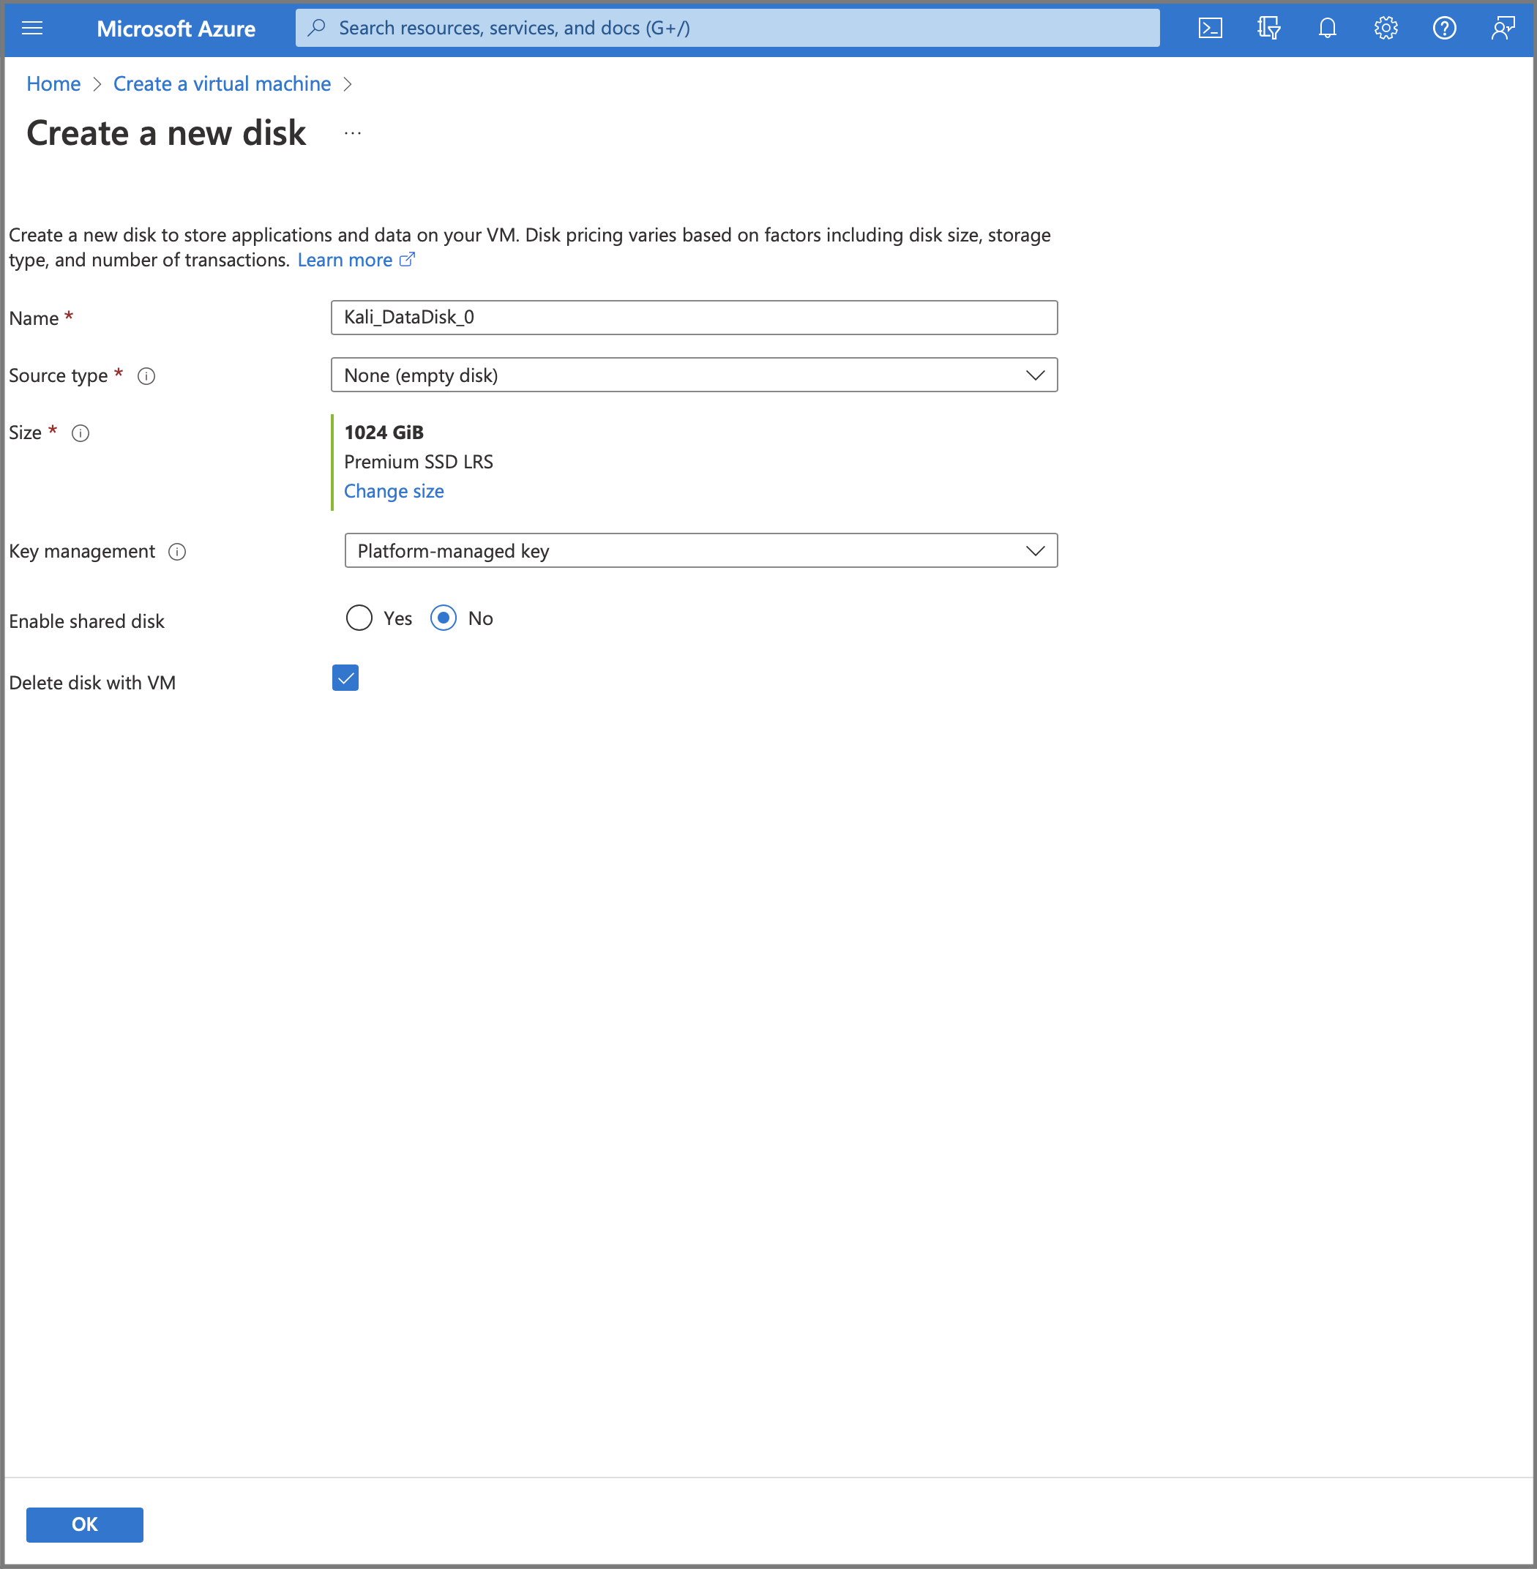  
      
    **You should now see the Data Disk created in the Disks tab.  
      
    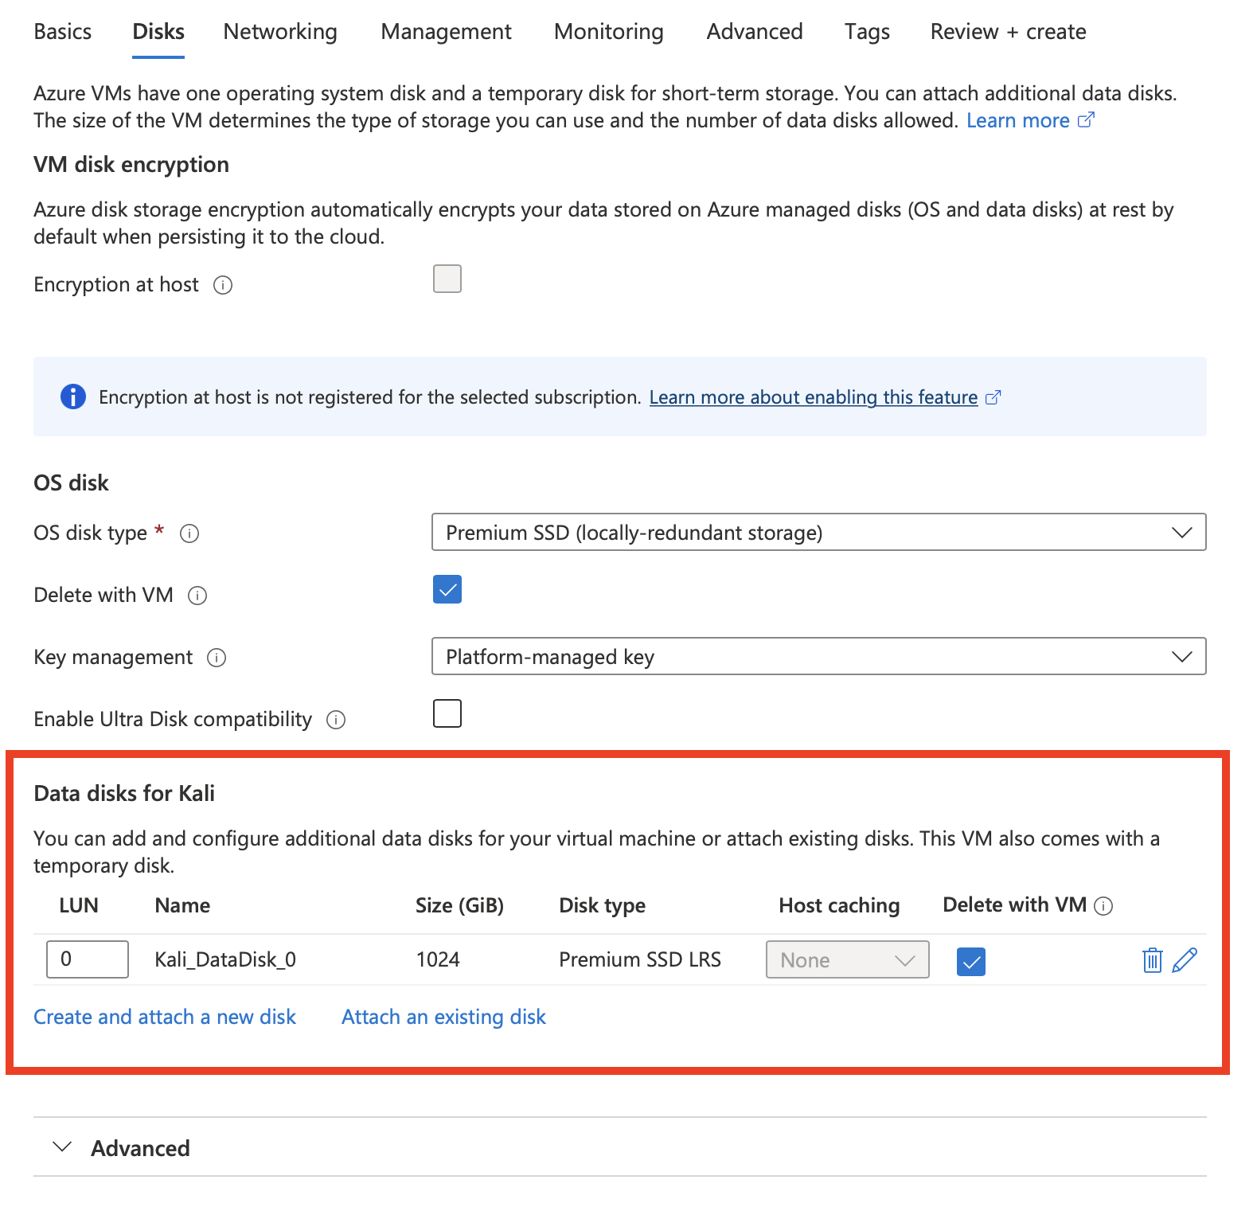**
12. Click **Next: Networking** to go to the next tab. In the **Networking** tab, under **Network interface**, in **Select inbound ports** field, select SSH (22) and RDP (3389).  
    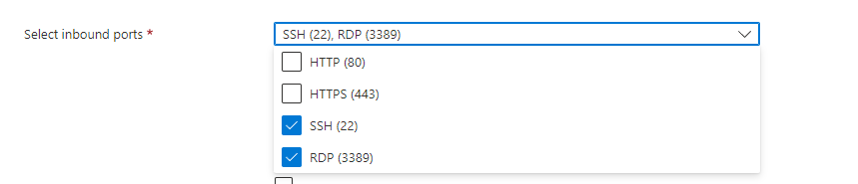
13. Leave the other defaults as is, and then click the **Review + create** button at the bottom of the page.
14. When you see the "**Validation passed**" message and have reviewed the details, click **Create**.
15. When the **Generate new key pair** window opens, select **Download private key and create resource**.  
    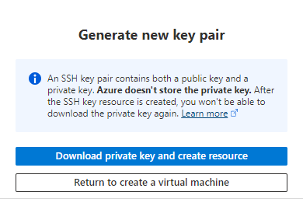  
    Your KEY-PAIR-NAME.pem file will be dowloaded.  
    ✏️ **Take note** of the save location of this .pem file and place it in a spot in your computer where you'll be able to find it later. We'll be using this later on!
16. Once the deployment is finished, select **Go to resource**.
17. On the page for your new VM, under the **Essentials** section, hover over the public IP address and select **Copy to clipboard**.  
    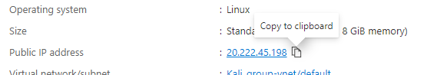

🎯 **Checkpoint 1**: By this point, your VM should be running and you are ready to connect to the virtual machine. You've made it this far!  Keep going!

#### **Step 2: Connect to the virtual machine**

Your virtual machine is running! Now we need to **access** it. To access the VM for the first time, we'll use [**ssh**](https://www.ssh.com/academy/ssh/protocol), a protocol that allows us to gain **remote access to the terminal** of another computer.

This means we won't see any pretty graphics (yet) -- ssh is just a terminal!

**Establish an SSH connection with your newly created virtual machine:**

1. Open a terminal window on your local physical host machine.
2. We'll use the command ssh -i YOUR-KEY-PAIR-NAME.pem username@IP_ADDRESS, where:
   * IP_ADDRESS is your Public IP Address and
   * YOUR-KEY-PAIR-NAME.pem is the path to your .pem
3. To get the path to your .pem, we recommend starting with the ~ home shortcut.
   * ~ redirects to your home folder, where Downloads, Documents, etc is stored

So to get the key in your Downloads folder, you could use ~/Downloads/azure_kali_key.pem  
ssh -i azure_kali_key.pem kali@20.222.45.198

1. Run the ssh command and connect:

ssh -i ~/Downloads/azure_kali_key.pem kali@20.222.45.198

📝 Note: If this is your first time connecting to your virtual machine via SSH, it will show a similar message:

The authenticity of host 'YOUR-VM-IP-ADDRESS (YOUR-VM-IP-ADDRESS)' can't be established.

ED25519 key fingerprint is SHA256:xxSHxwRiodjx4xBQDAx2xxCNbxdHx8xPLyTx3SkLdUbex1.

This key is not known by any other names

Are you sure you want to continue connecting (yes/no/[fingerprint])?

When first time establishing an SSH connection with the VM, you will be asked to verify the authenticity of the host that you are connecting to.

* Don’t be tempted to just accept the key fingerprint presented! This can possibly expose you to **Man-In-The-Middle attacks**! You should always validate the fingerprint before responding "yes".
* You can get the host fingerprint of your VM in the Azure portal by using one of these two options:

Using the **Run command** and choosing **RunShellScript** from the list of Run commands

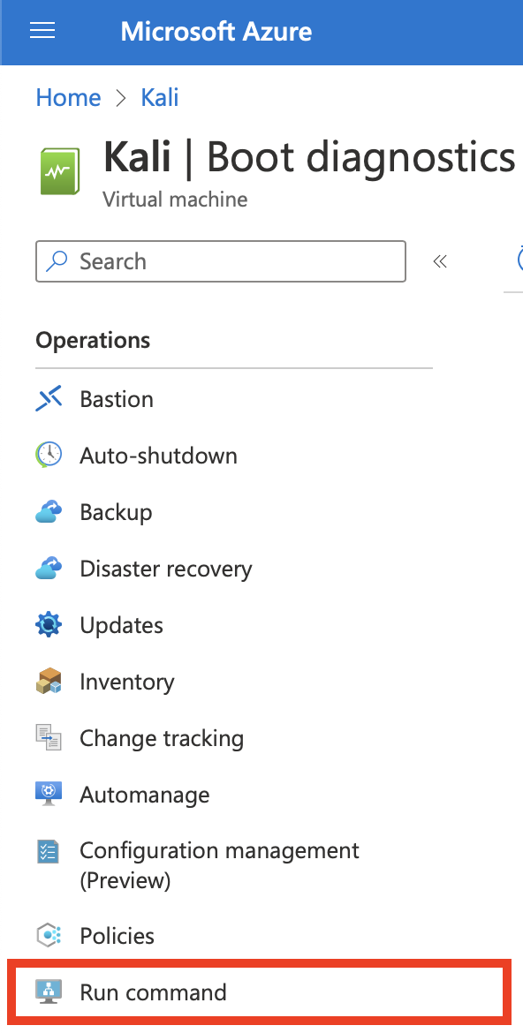

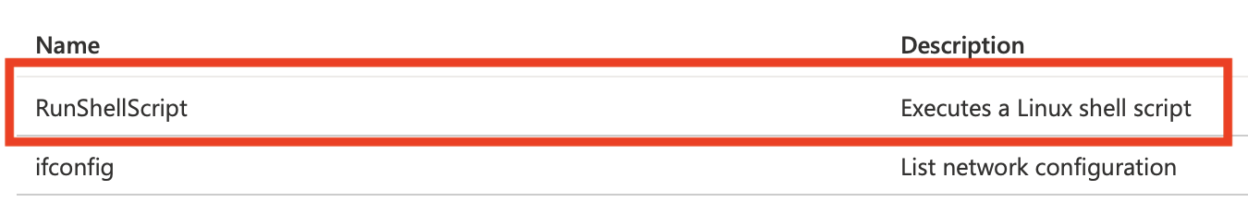

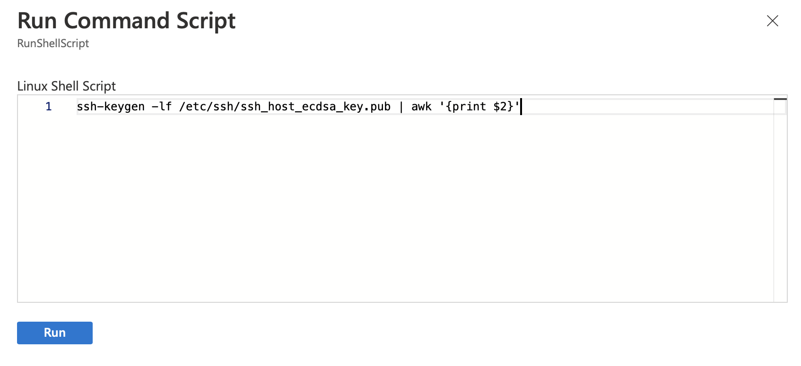

Using the **Serial log** in **Boot diagnostics** to find the host key ***(recommended)***

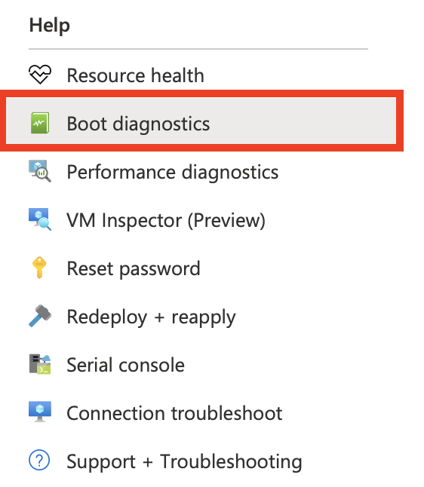

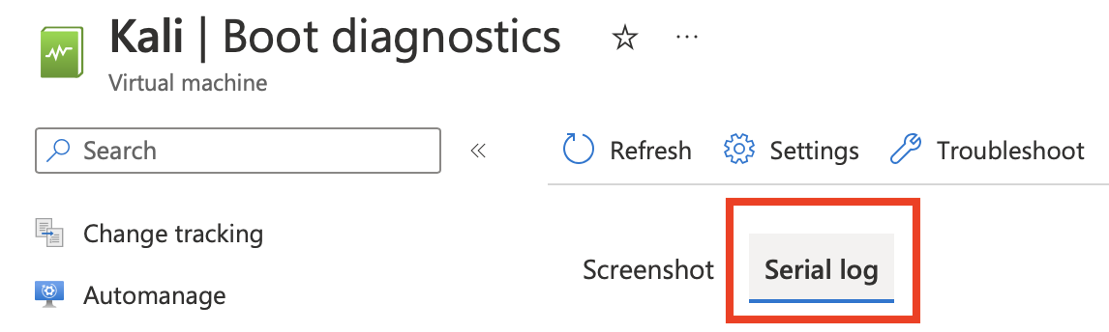

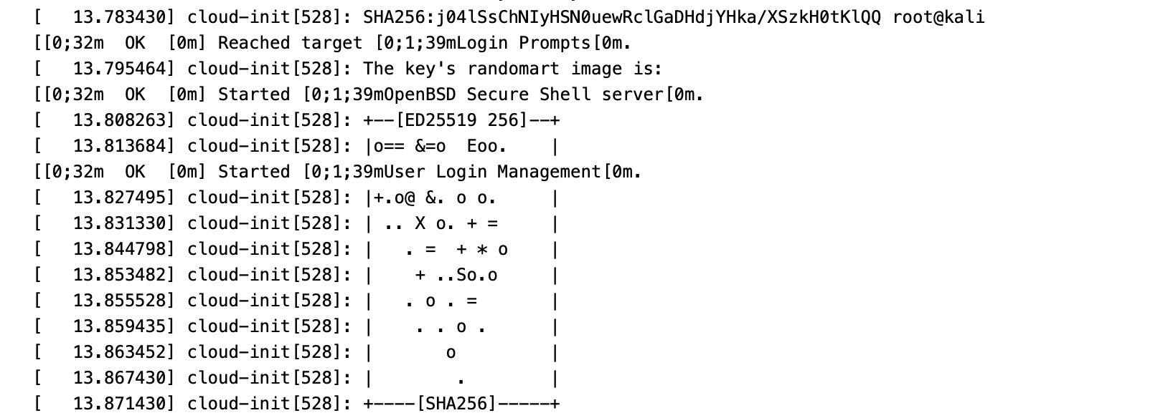

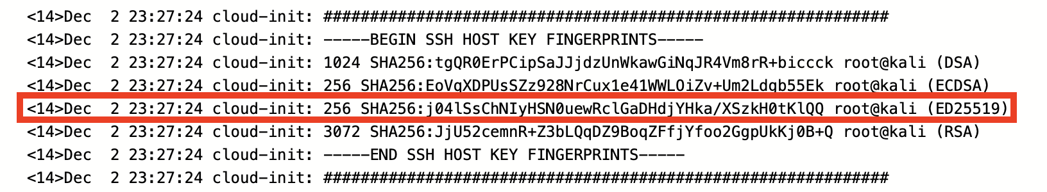

If you compare the fingerprint from the prompt with the one from your virtual machine and it matches, you've been able to verify the fingerprint. You can then type yes to authorize and connect to the virtual machine. You should now see the prompt for your VM!

**COMMON ISSUES & FIXES**

⚠️ "UNPROTECTED PRIVATE KEY FILE" Error

In case you see a similar message after you try to connect to your Azure virtual machine:

@@@@@@@@@@@@@@@@@@@@@@@@@@@@@@@@@@@@@@@@@@@@@@@@@@@@@@@@@@@

@ WARNING: UNPROTECTED PRIVATE KEY FILE! @

@@@@@@@@@@@@@@@@@@@@@@@@@@@@@@@@@@@@@@@@@@@@@@@@@@@@@@@@@@@

Permissions 0644 for 'Kali_key.pem' are too open.

It is required that your private key files are NOT accessible by others.

This private key will be ignored.

Load key "YOUR-KEY-PAIR-NAME.pem": bad permissions

azureuser@YOUR-VM-PUBLIC-IP-ADDRESS: Permission denied (publickey).

If we take a look at the file, we notice that it has write permissions assigned to it, and can be changed by anyone without needing administrator privileges. Let's type ls -l to see the file's permissions:



Since we want this file to remain protected, you'll need to change the permissions on the file before trying to connect again via SSH (please see this [file permissions article](https://www.guru99.com/file-permissions.html) to read more about it). In the terminal window, type the following command:

chmod 400 YOUR-KEY-PAIR-NAME.pem

We can use the site [chmodcommand.com](https://chmodcommand.com/chmod-400/) to help us see what we changed. Searching for the command chmod 400, we can see that this allows our users to read the file, yet removed the permissions to write or execute the file. Typing ls -l to review the permissions again, we see this result:

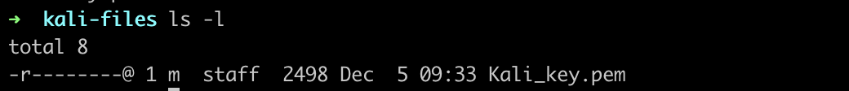

These changes should allow us to connect via SSH to the virtual machine. Try connecting via SSH again -- if you see something similar to the following terminal prompt, then it means you were able to connect successfully!

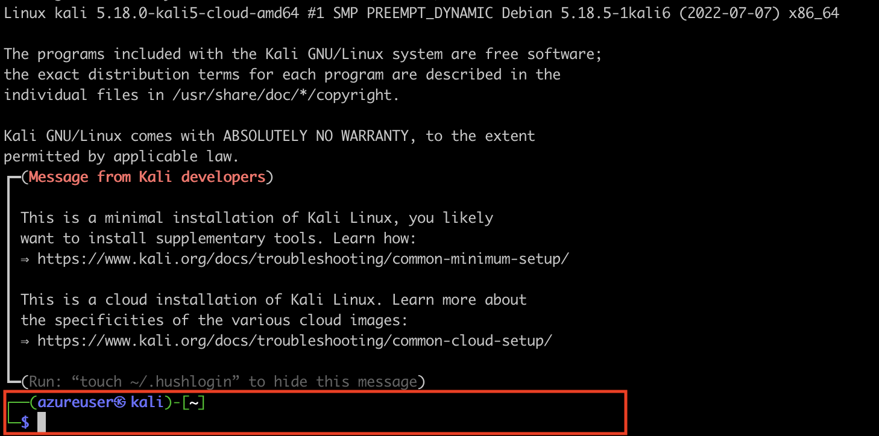

⚠️ Connection Time-out Error

If a **connection time out** displays when trying to SSH to the virtual machine, check that:

* Your virtual machine is installed successfully in the cloud
* Your virtual machine is up and running in Azure (the Start button in the Azure Portal will be disabled)
* You can also try restarting the virtual machine with the Restart button in the Azure Portal and trying to log in again

Once connected, you should see a Kali terminal prompt!

┌──**(**kali㉿kali**)**-[~]

└─$

Try out some of the following commands to get info about the system:

* uname -a
* lsb_release -a
* whoami

#### **Step 3: Setup RDP**

The Kali terminal is extremely useful, but it can be intimidating if you're not used to working on a terminal. In this step, we'll develop the alternative option: Connecting to your Kali VM via Remote Desktop Connection. This will let you see a Desktop, run graphical programs, and interact the the Kali machine in a more traditional way. (We will be using a hybrid of ssh and rdp throughout this course.)

You will install and configure a desktop environment ([xfce](https://www.xfce.org/)) and remote desktop ([xrdp](http://xrdp.org/)) for your Kali VM.

Linux virtual machines don't come with default desktop environments. Linux virtual machines are usually managed via SSH connections. You can choose from a variety of desktop environments in Linux. Here you will be using the xfce and xrdp.

##### **Install a desktop environment on your Kali VM**

1. Connect to your VM via SSH.

Install xfce with the following:  
sudo apt-get update

sudo DEBIAN_FRONTEND=noninteractive apt-get -y install xfce4

sudo apt install xfce4-session

##### **Install and configure a remote desktop server**

Next, configure a remote desktop service to listen for incoming connections.

Install xrdp on your Kali VM by running the following command:  
sudo apt-get -y install xrdp

sudo systemctl enable xrdp

Execute the following command to add the xrdp user to the ssl-cert group:  
sudo adduser xrdp ssl-cert

Set xrdp to use xfce as your desktop environment when you start your session. To do this, run the following command:  
echo xfce4-session >~/.xsession

Use the following command to restart the xrdp service for the changes to take effect:  
sudo service xrdp restart

🎯 **Checkpoint 2**: As of this point, xrdp has been installed in your Kali VM, and you have configured xfce as the remote desktop environment!

##### **Set a local user account password**

📝 Note: You can skip this section if you created a password for your user account when you created your virtual machine.

If you use SSH key authentication and do **not** have a password set for your local account:

* Specify a password before you use xrdp to log in to your VM. xrdp cannot accept SSH keys for authentication. Run the following command to set a password for the user account azureuser:

sudo passwd azureuser

It will prompt you for the new password and ask you to confirm it. After you finish entering the password, you should see a message to confirm that the password updated successfully.

passwd: password updated successfully

##### **Connect a Remote Desktop client**

Follow instructions for this step based on your host operating system:

**🪟 Windows OS**

1. 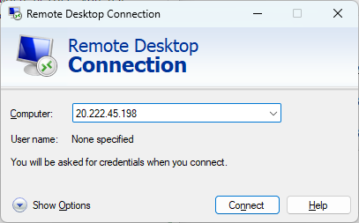
2. **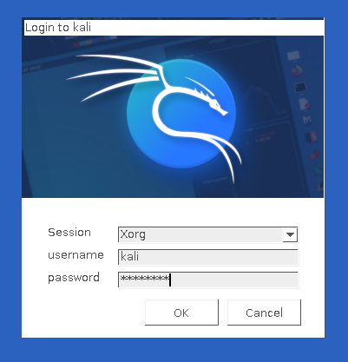  
   **

* **🍏 macOS option 1 (manual)**

1. [**Download Microsoft Remote Desktop**](https://apps.apple.com/us/app/microsoft-remote-desktop/id1295203466?mt=12) **from the Apple Mac App Store. When it's done downloading, open the app.**

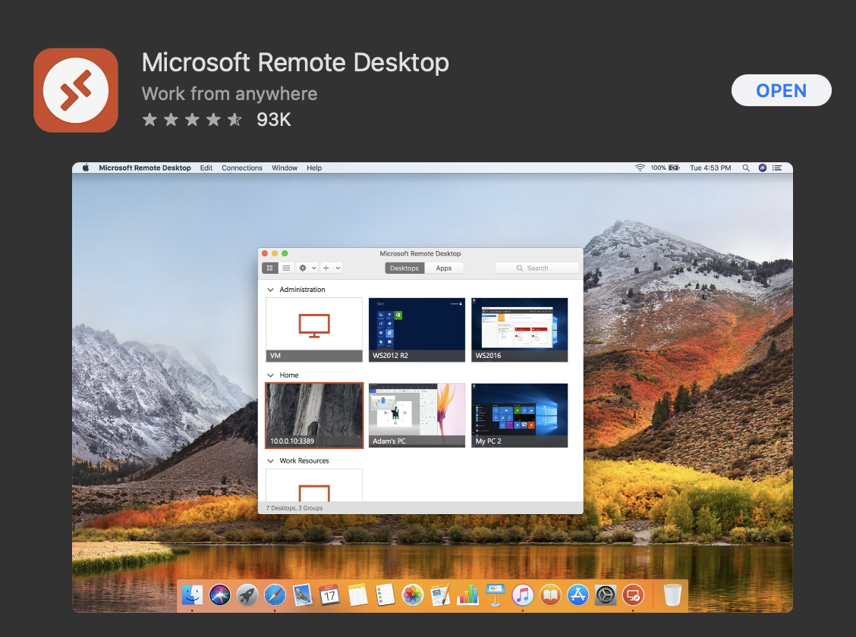

1. **Click on the "Add" button to add a PC. Alternatively, you can also click the + button in the top bar and select "Add PC".**

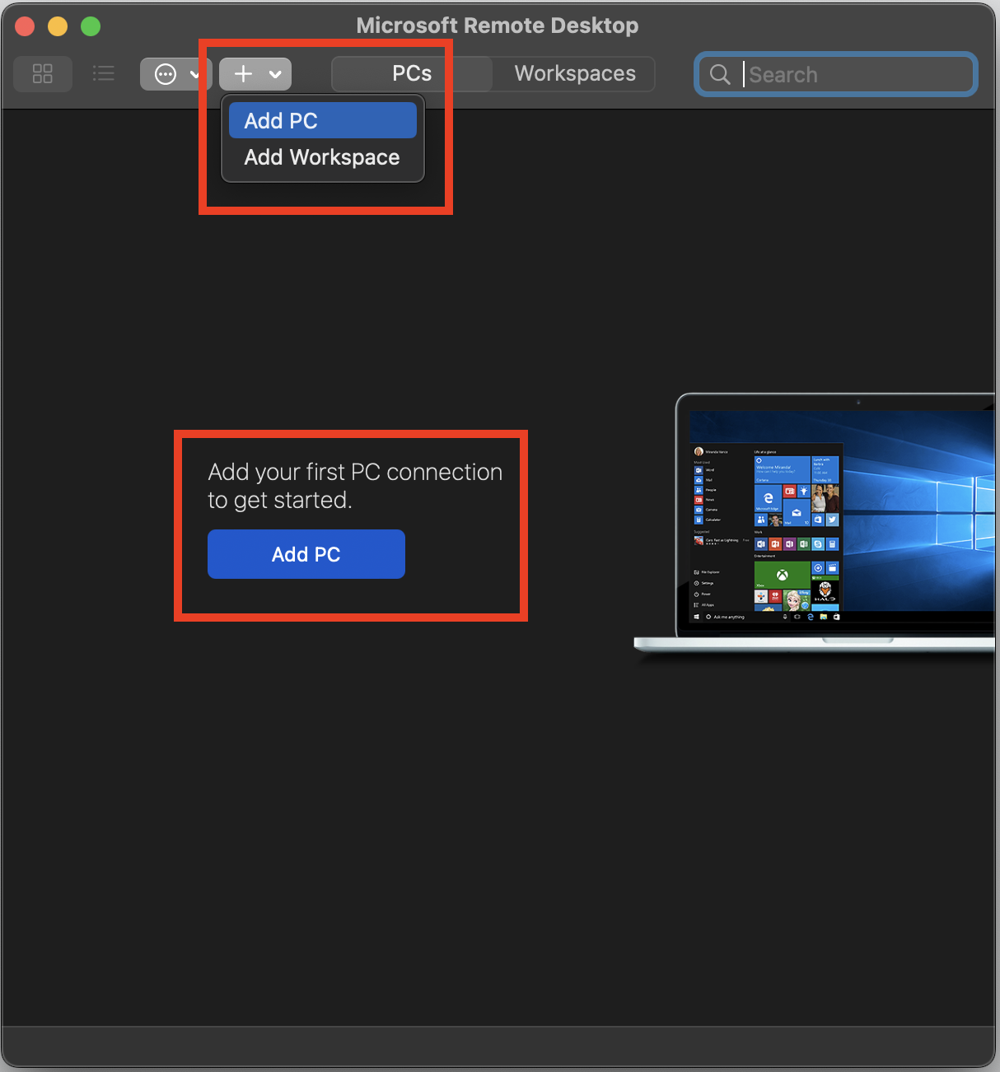

1. **A form will appear to Add a PC. Enter your Kali VM Public IP address in the PC name field. All the other fields can be left as is.**

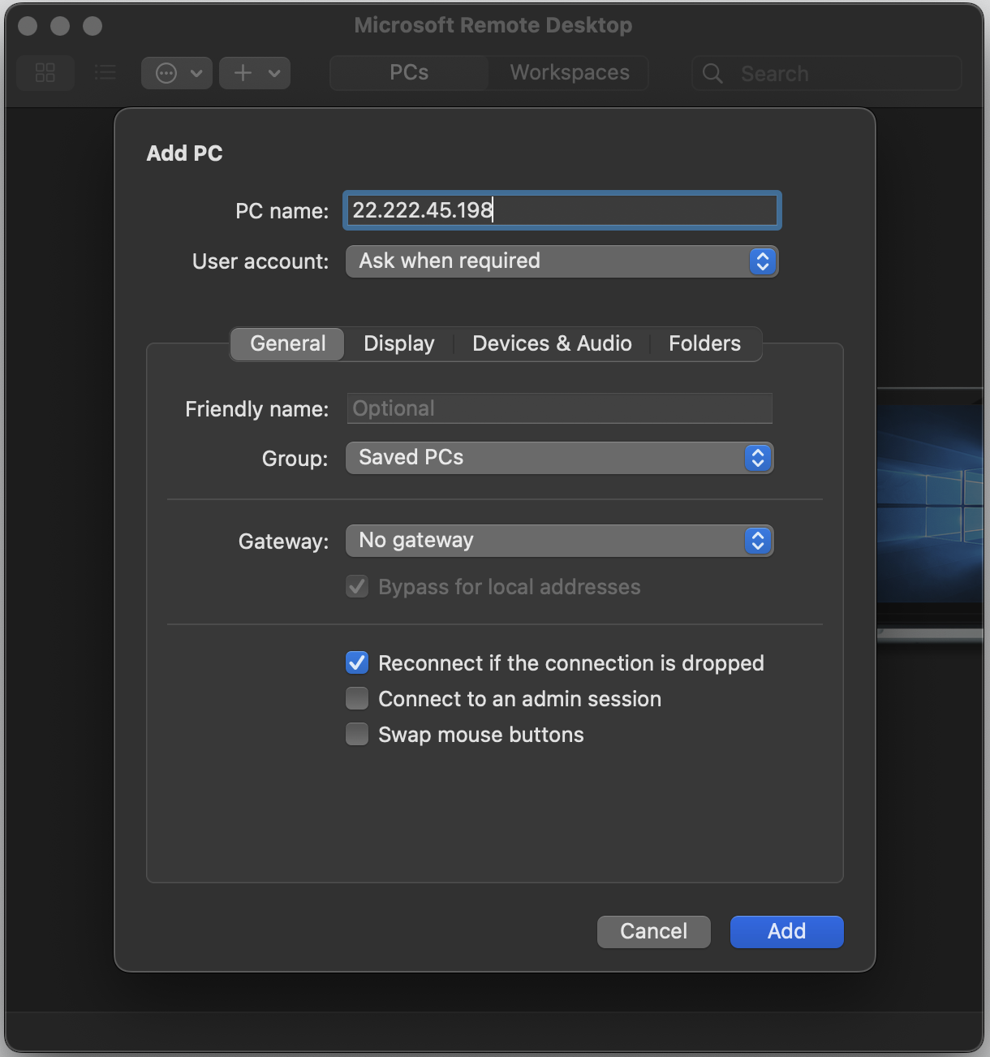

1. **For the User Account field, click the dropdown and select "Add a User Account...". It will take you to another menu.**

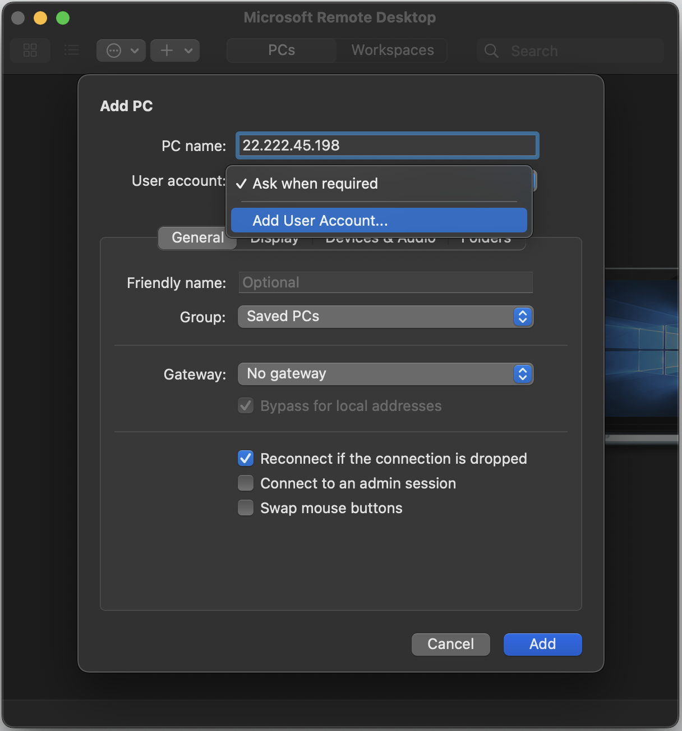

1. **In the next pop up, type in the username and password for that you set for the account. You can leave the "Friendly Name" blank. When you are done, click "Add".**

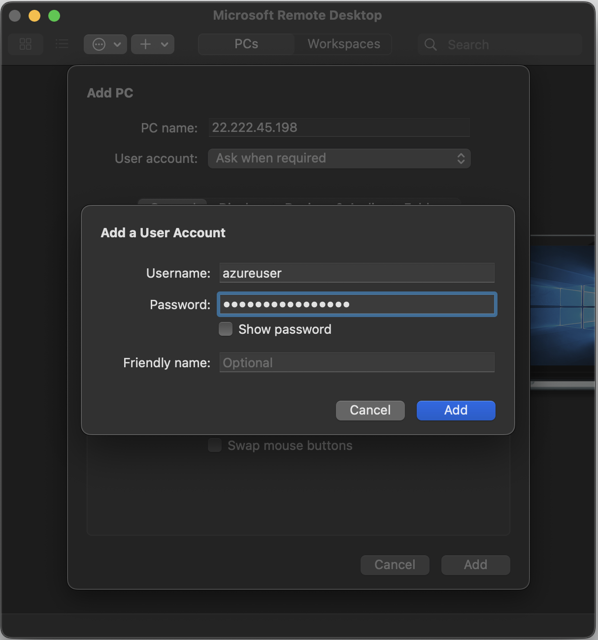

1. **The previous form will show again, and now the user account should be selected. Click on the "Add" button.**

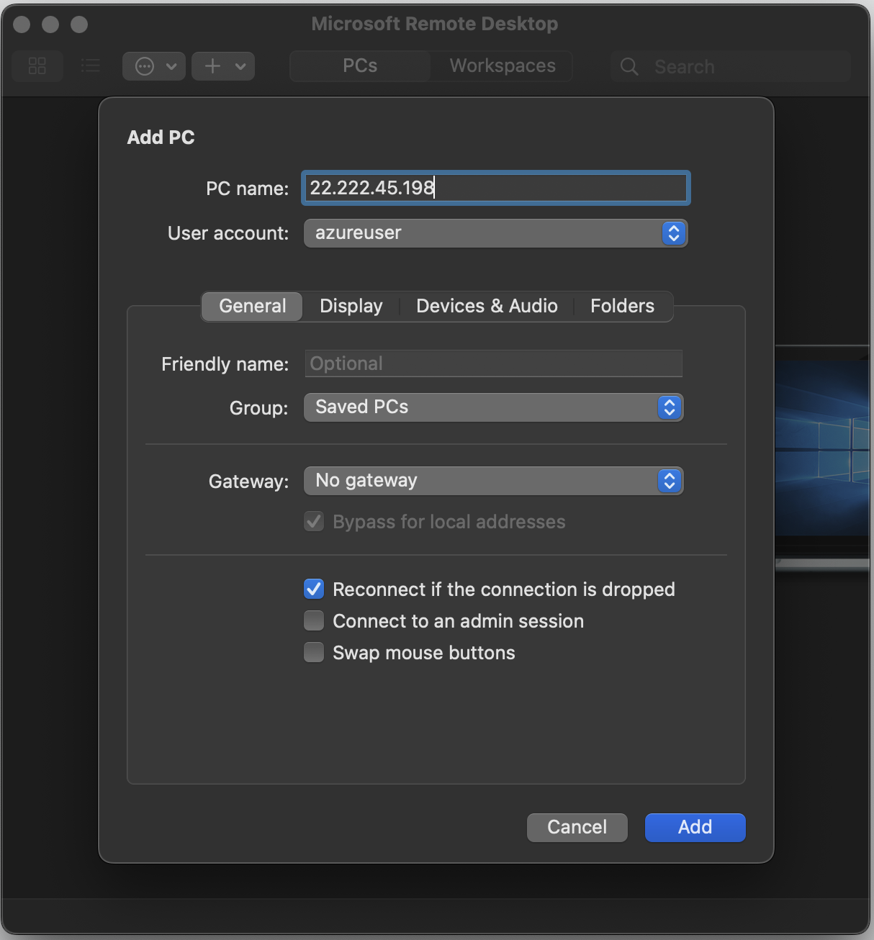

1. **Your Remote Desktop window should now show your Kali VM**

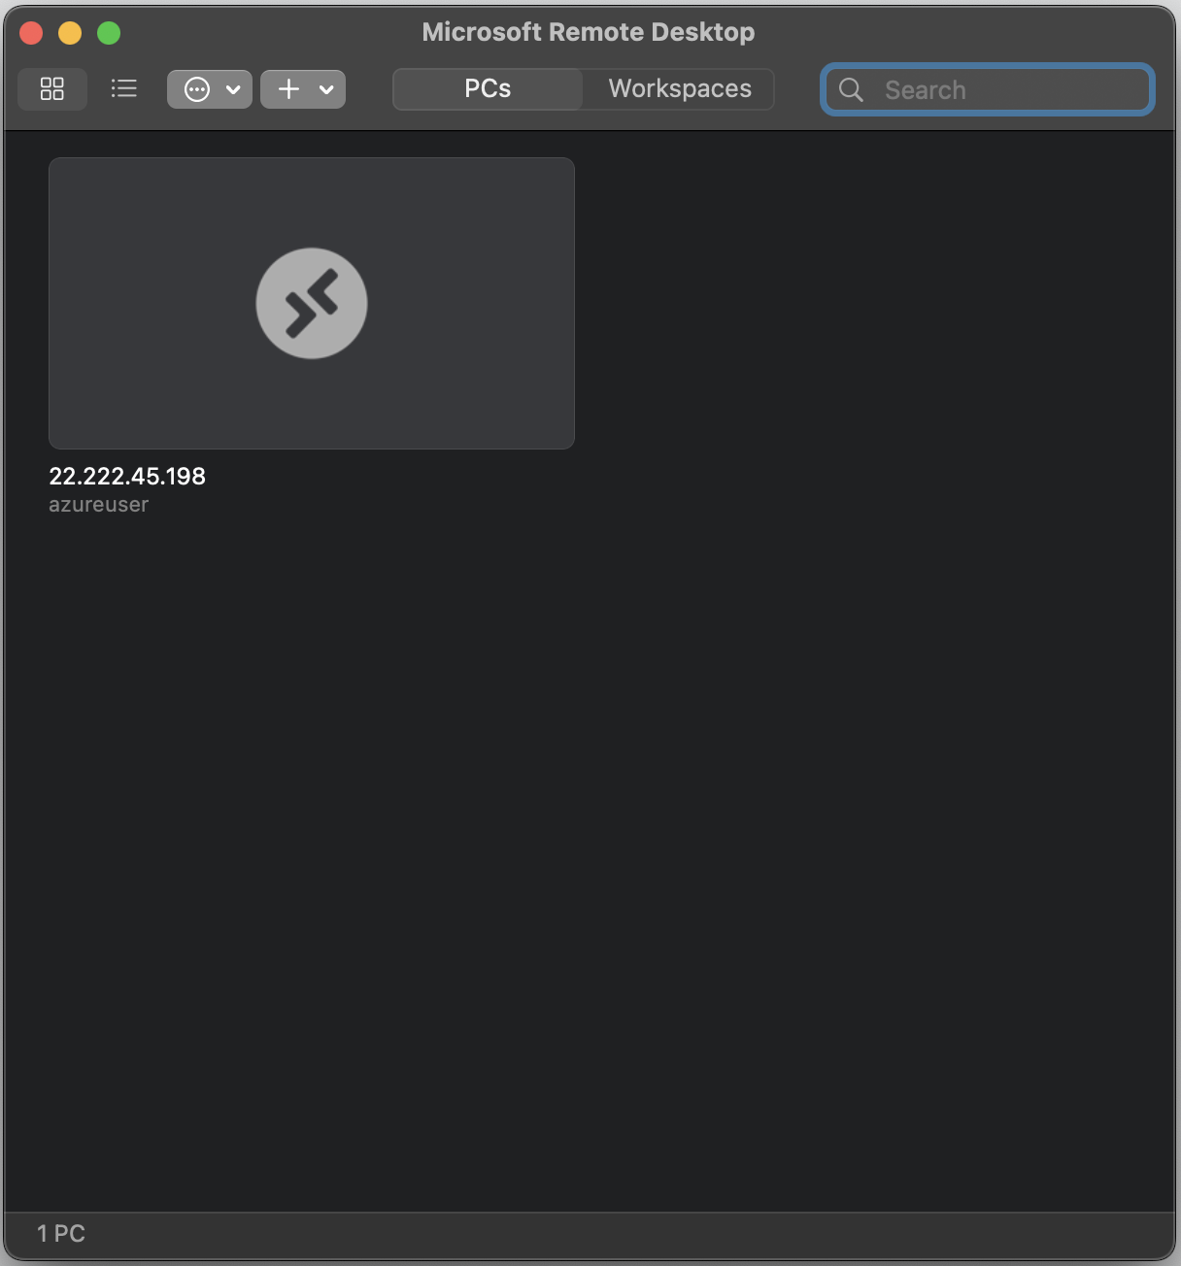

1. **To connect to you VM, double click on your virtual machine in the window. It should begin connecting:**

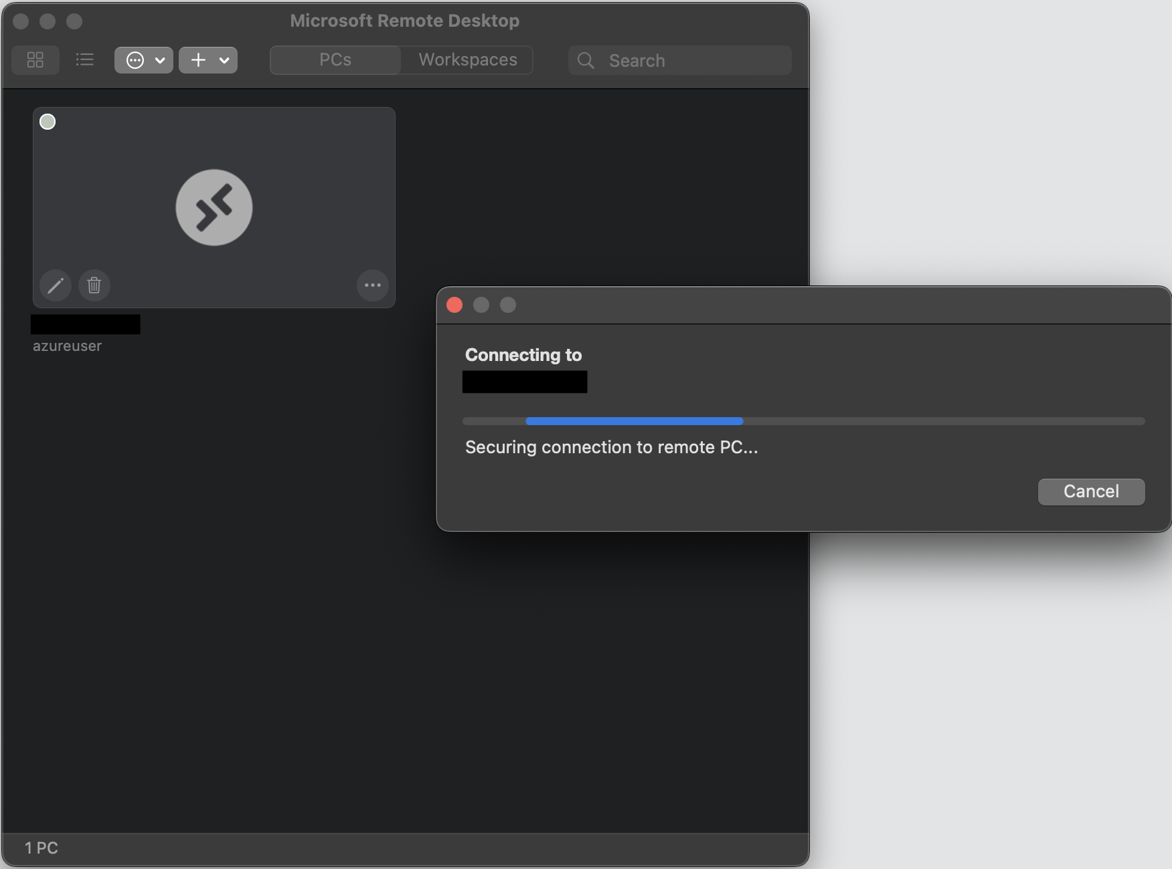

1. **It will give a warning about the certificate not being verified. Since we have a self-signed certificate created on set up, we will click "Continue" on this message. Under other conditions, you would want to make sure you verify certificates before connecting through RDP in this way.**

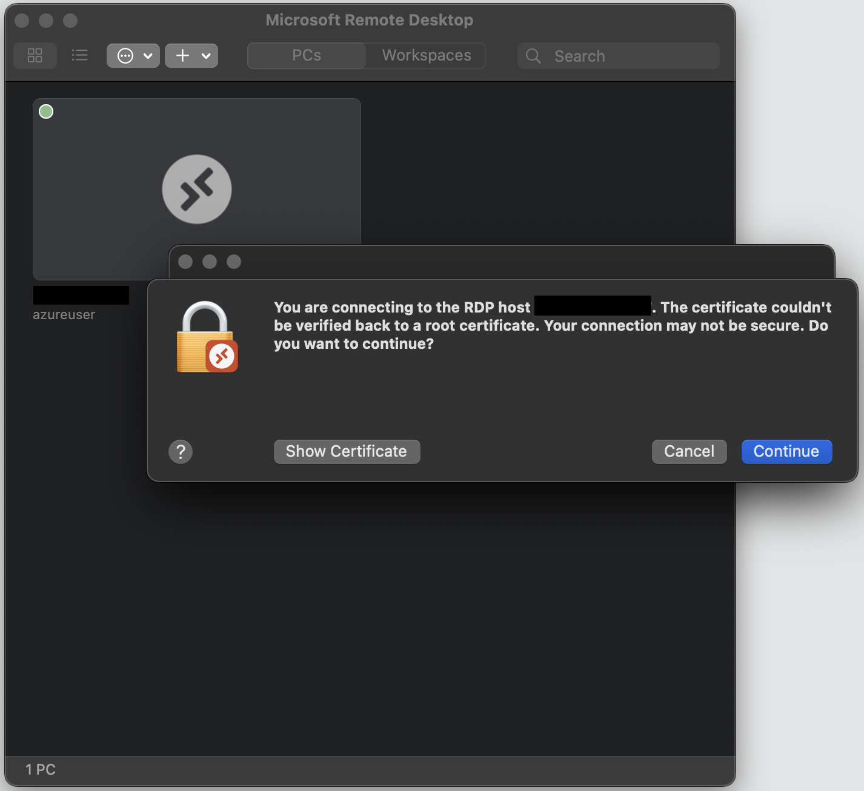

1. **After clicking "Continue", it will continue connecting to the virtual machine. On successful login, you should see it launch in a new window:**

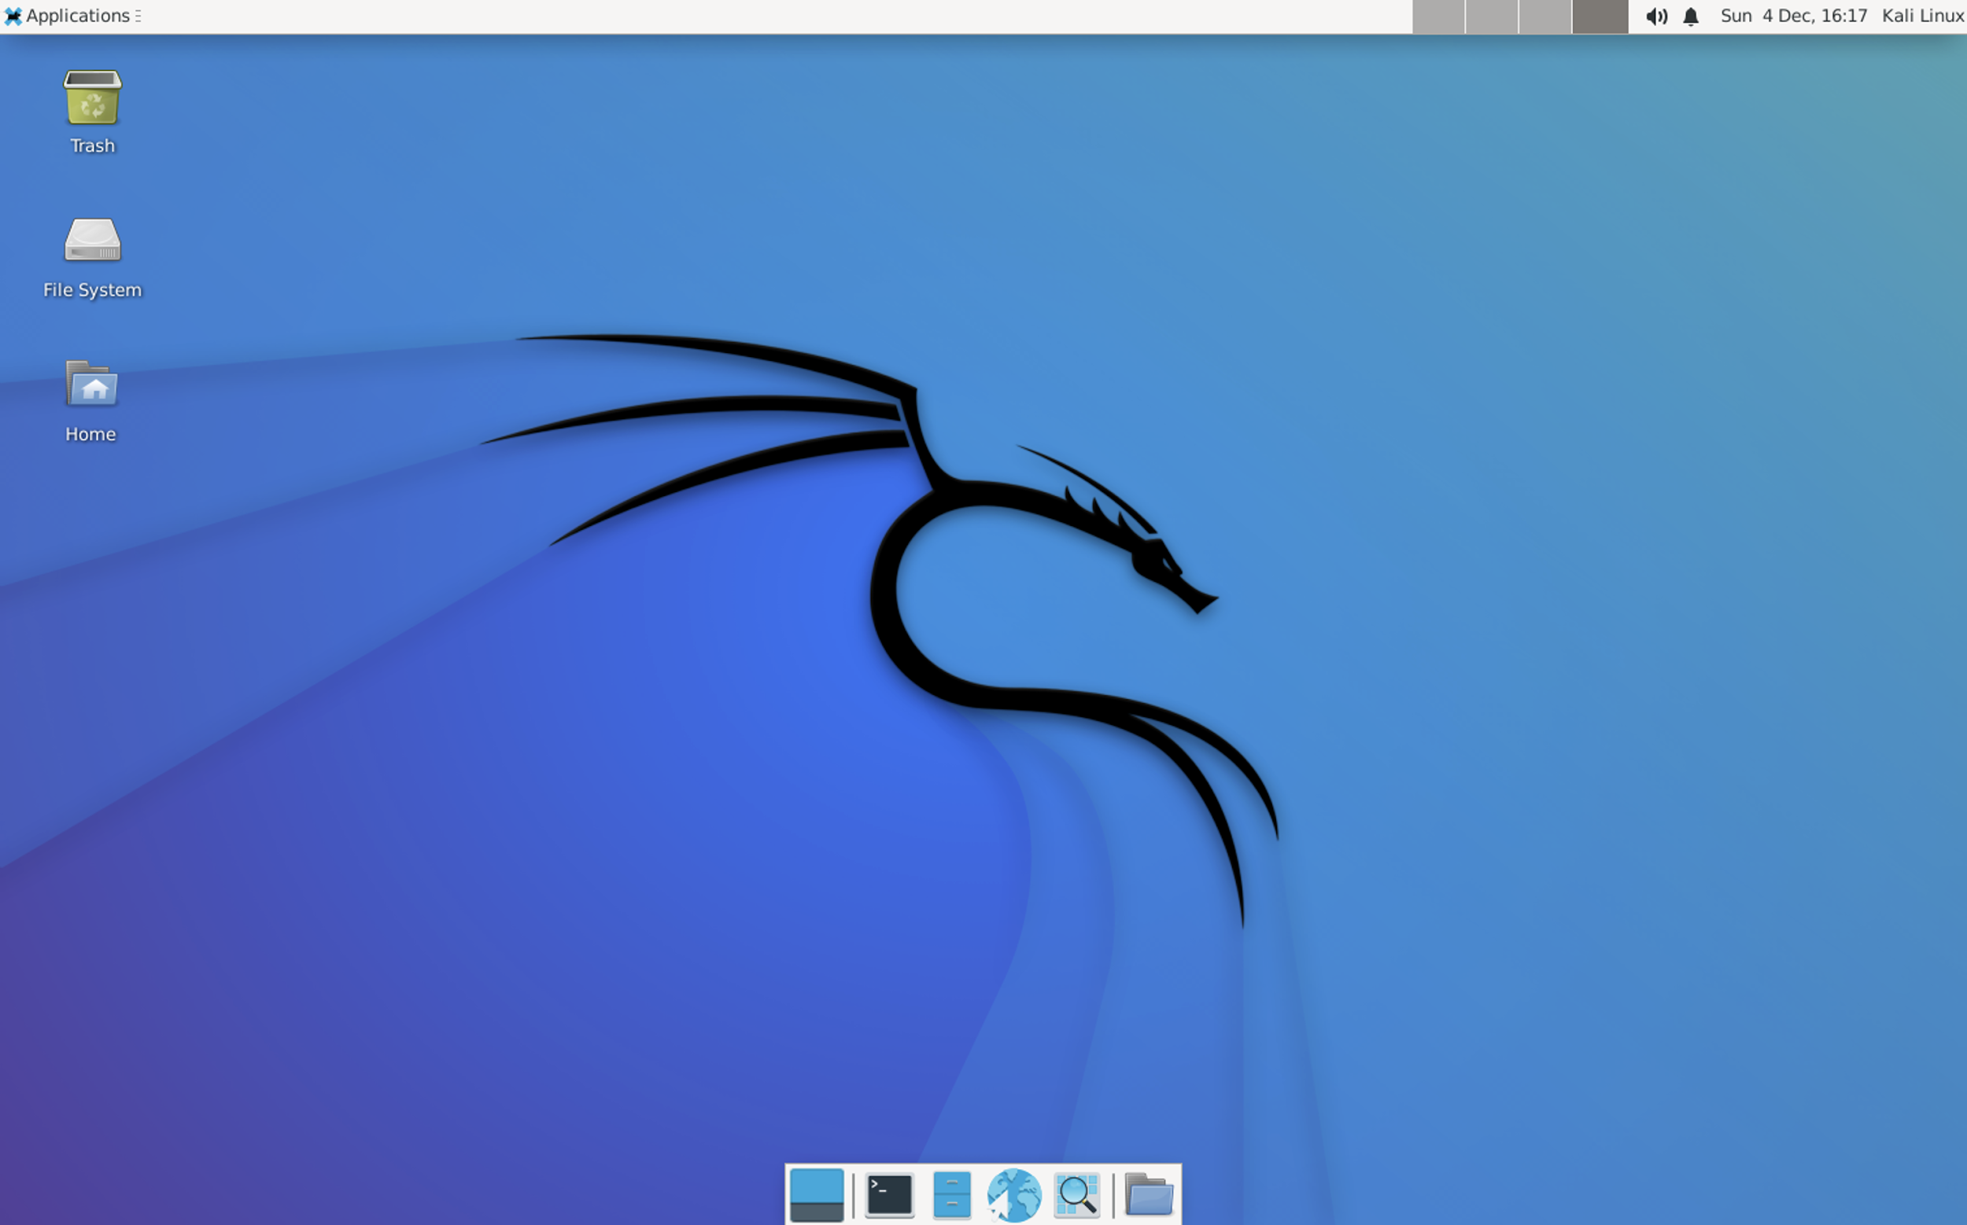

* **🍏 macOS option 2 (Azure RDP file)**

[**Download Microsoft Remote Desktop**](https://apps.apple.com/us/app/microsoft-remote-desktop/id1295203466?mt=12) **from the Apple Mac App Store. When it's done downloading, open the app.**

**<img src='https://i.imgur.com/Zvc0dAF.png' title='Microsoft Remote Desktop' width='500' alt='Microsoft Remote Desktop' class='center-block' />**

**In the Settings section in the Azure Portal, click on the Connect option:**

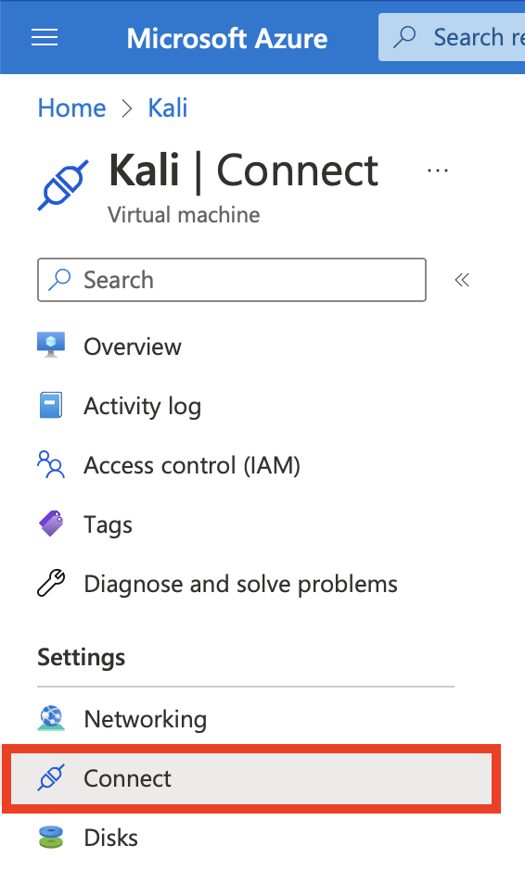

**You can also access it from the Connect dropdown at the top of the Overview section for the virtual machine:**

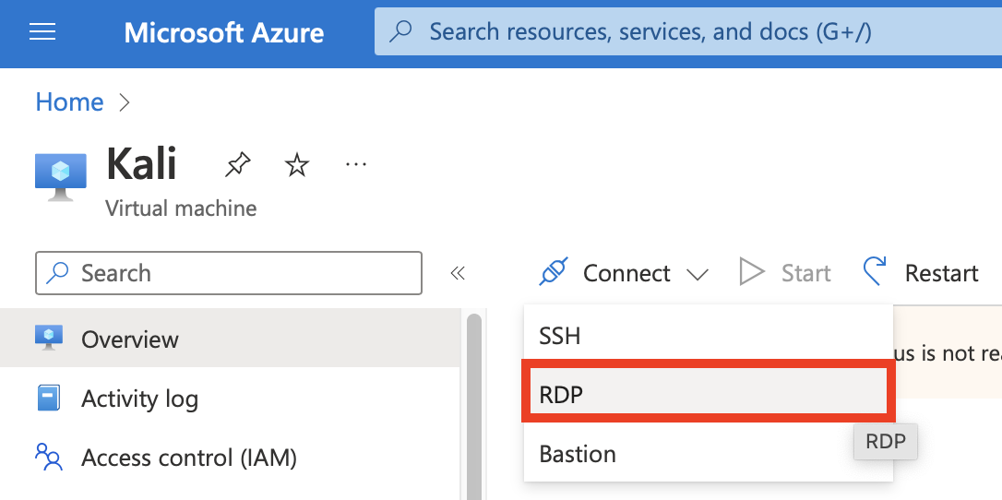

**In the next screen on the RDP tab, ensure that your public IP address is selected in the dropdown, as well as port 3389. After confirming, click on the Download RDP File button. This will download a .rdp file to your computer.**

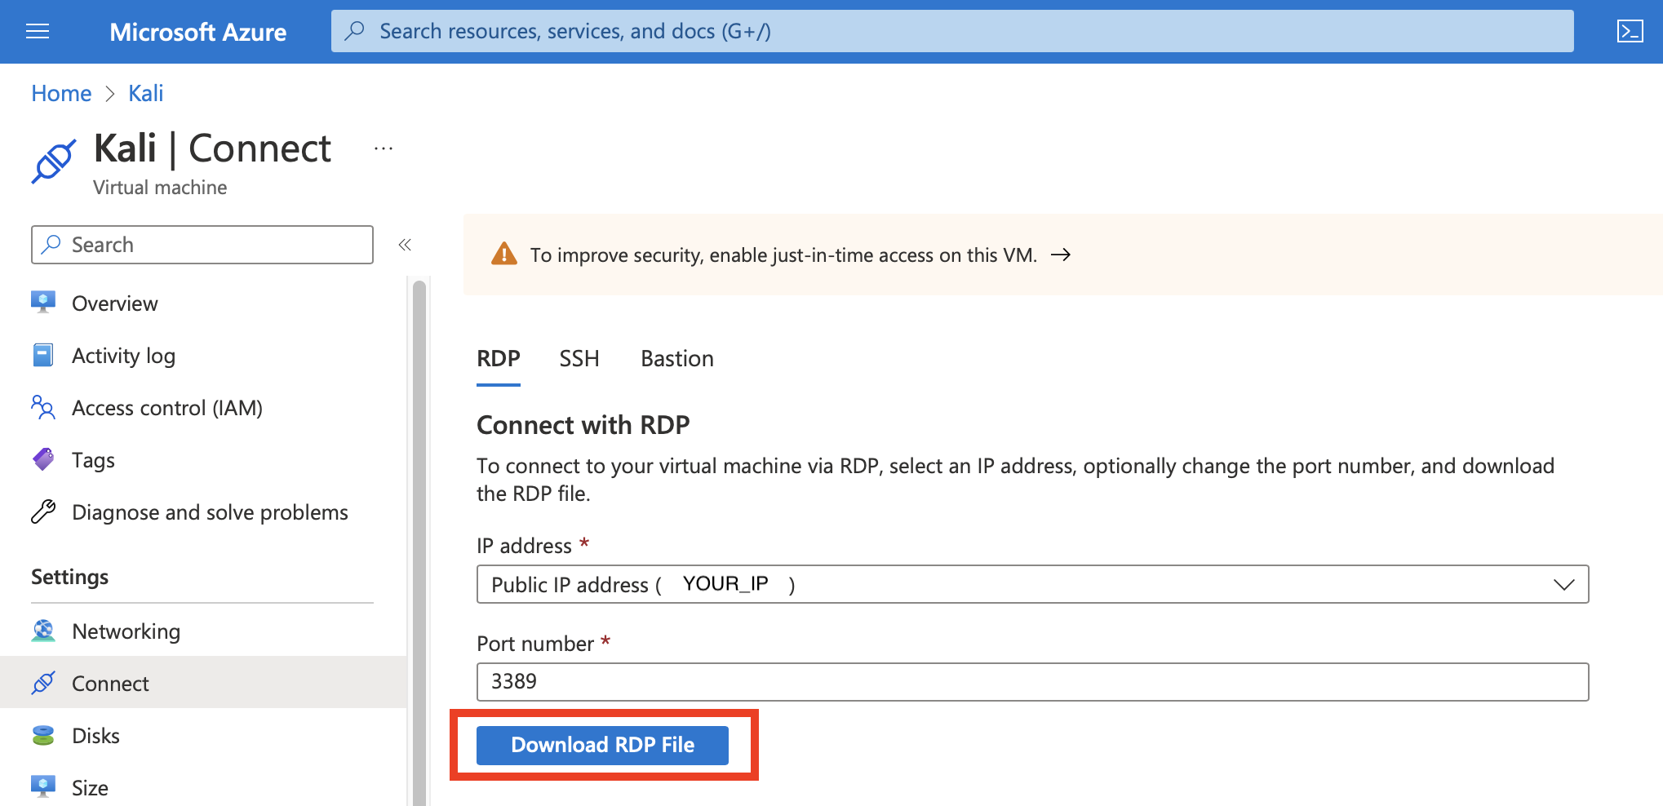

**Your .rdp file will be named after your virtual machine name:**



**Open the folder where you saved the .rdp file. Drag and drop the file into the Remote Desktop Client window.**

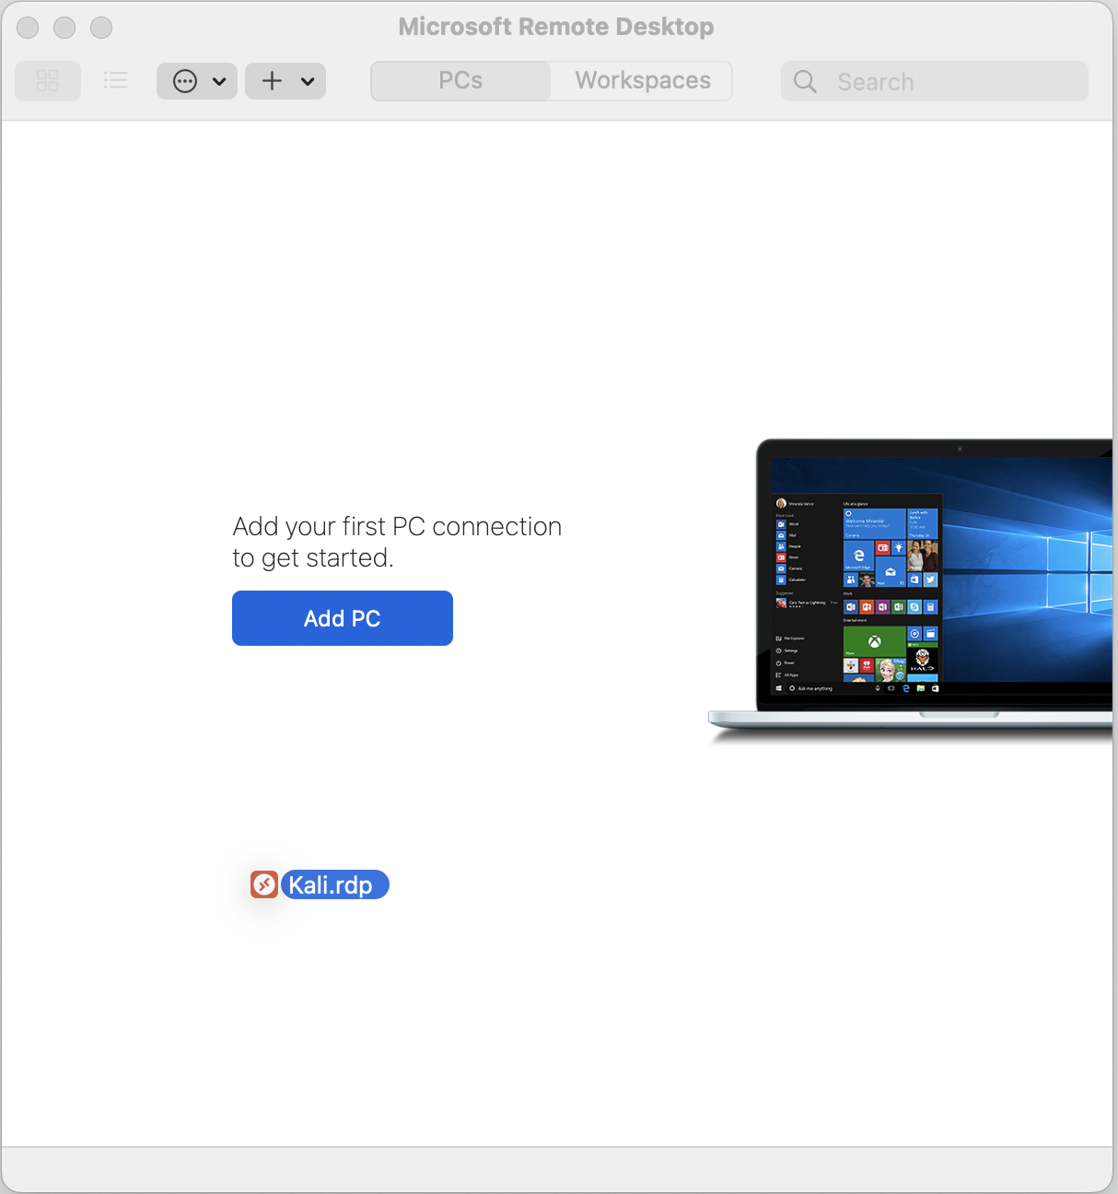

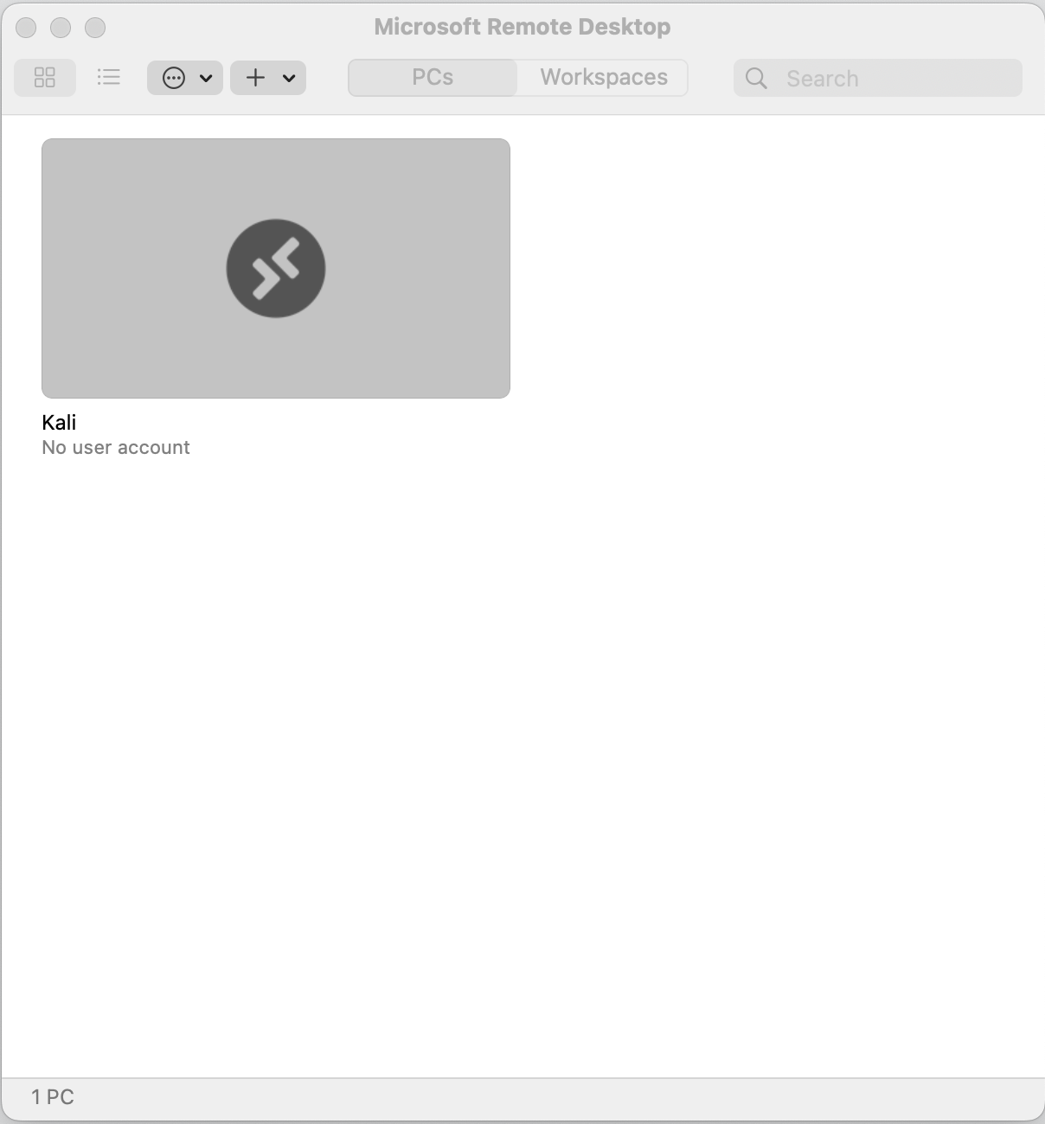

**Double click on the virtual machine to connect to you VM. It should begin connecting, and will give a warning about the certificate not being verified. Since we have a self-signed certificate created on set up, we will click "Continue" on this message. Under other conditions, you would want to make sure you verify certificates before connecting through RDP in this way.**

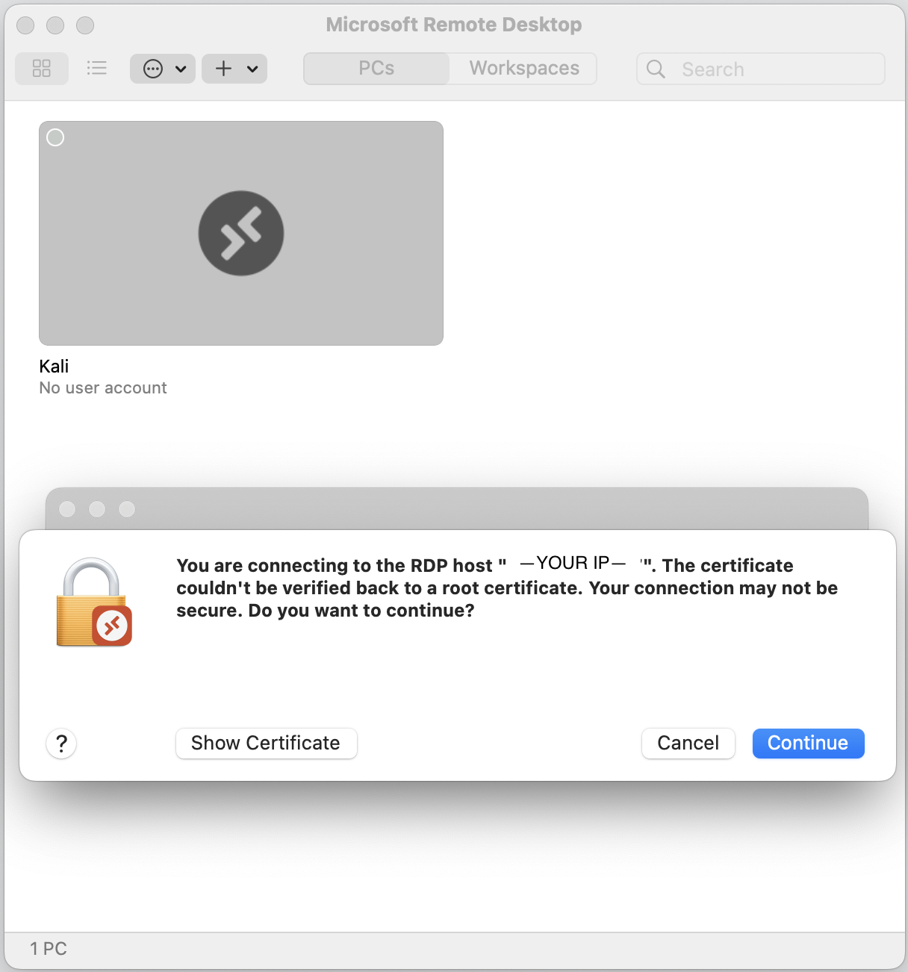

**Enter your user credentials at the next prompt.**

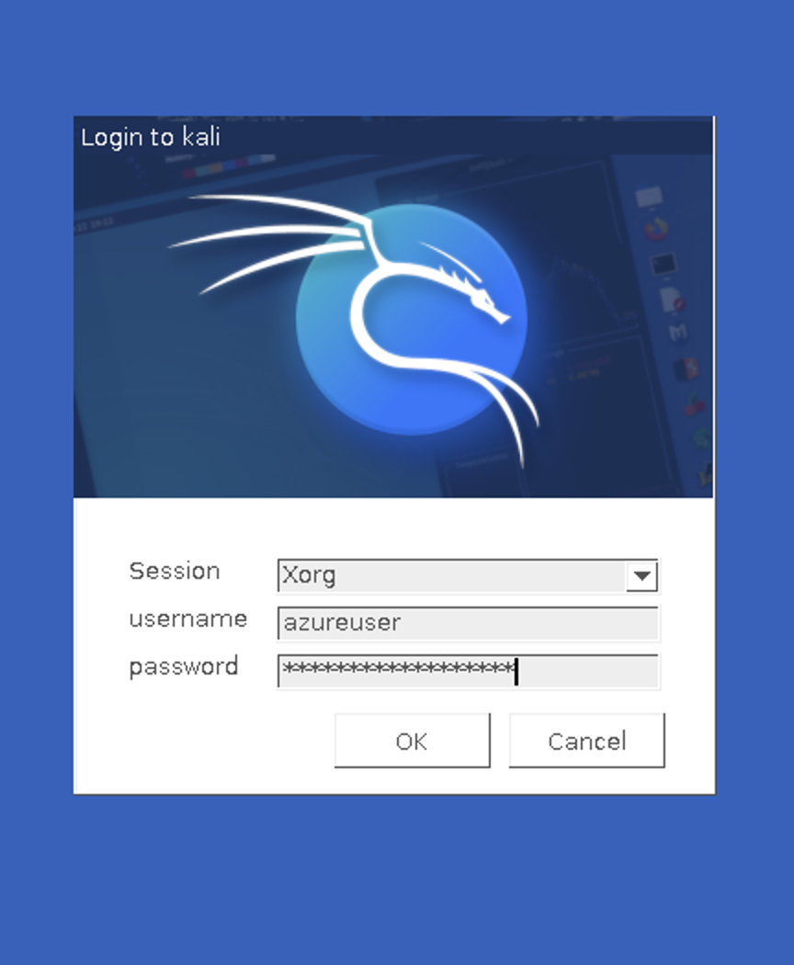

**You'll be shown one more popup to configure a color managed device. Enter your password to configure this setting and click "Authorize".**

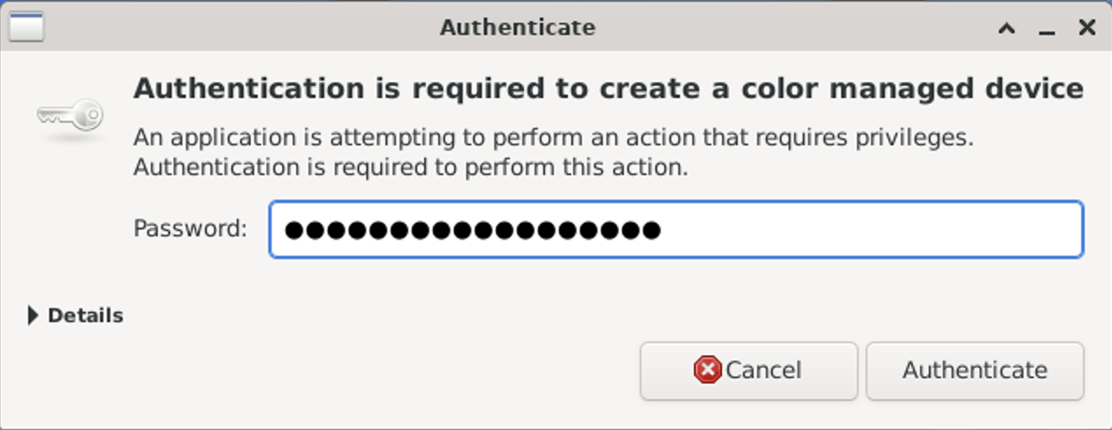

**You should now be able to log in and view your virtual desktop! 🎉**



**🐧 Linux OSes**

**For Linux distributions, we recommend following the macOS steps above using an RDP client like** [**Remmina**](https://www.remmina.org/)**.**

**Close Section**

When you're done, you should have a Remote Desktop Connection to your Kali machine:



🎯 **Checkpoint 3**: You have just configured the Remote Desktop Client to connect to your virtual machine! This will be an important method of connecting to your Kali Linux machine throughout this course.

🎉 You have successfully completed the required features in this lab! Congratulations! 🎉

If you have time left over, continue on to the stretch features to do some fun things with your Kali box!

### **Stretch Features**

#### **Step 4: Host a Super Mario game in your web server**

In this step, we will add a Super Mario game in your web server using Docker container.

💡 Expand this to learn more about Docker

* *What is Docker?*
  + "**Docker** is a software platform for building applications based on containers—small and lightweight execution environments that make shared use of the operating system kernel but otherwise run in isolation from one another. While containers have been used in Linux and Unix systems for some time, Docker, an open source project launched in 2013, helped popularize the technology by making it easier than ever for developers to package their software to “build once and run anywhere.”"
* *What is Container?*
  + "**Containers** are lightweight, standalone package of software that contains anything you need to run an application. It offers a logical packaging mechanism in which application can be abstracted from environment in which they actually run."

The following are the steps on how to add a docker container on your web server which hosts a Super Mario Bros. game:

**Setting up Docker**

Before deploying Mario game on Docker container, we need to install Docker first.

Open a Kali terminal (ssh or rdp), then download and install the latest version of Docker to your VM:  
sudo apt install -y docker.io

Start the Docker daemon after successful installation:  
sudo systemctl start docker

To verify that it is running, run the following command:  
sudo systemctl status docker

1. Press q key to exit the log.

**Deploying Super Mario game on Docker container**

Search for the Super Mario game image from the Docker registry:  
sudo docker search pengbai/docker-supermario

1. 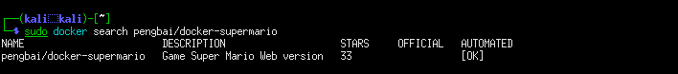

Pull the image from the registry:  
sudo docker pull pengbai/docker-supermario

Retrieve the Image ID by running the following command:  
sudo docker images

1. 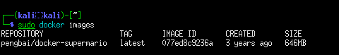

Run the container and map port 8600 on Docker host to port 8080 on the container where the Super Mario game application is running.  
sudo docker run -d -p 8600:8080 077ed8c9236a

1. 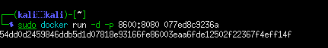

Verify if the container is running:  
sudo docker ps

1. 

**Playing the Game**

To access your Mario game, you'll need a web browser! Let's install a simple one called Falkon:  
sudo apt install -y falkon

1. From an RDP connection to Kali, open a Falkon web browser window.
   * (You can find it in the top-left menu under Applications -> Internet -> Falkon)
2. 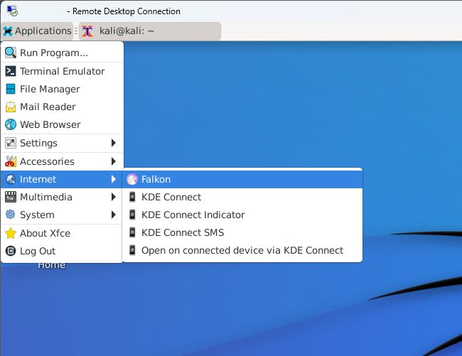
3. Access the container using your web server public IP address with the port you specified on the previous step:  
   [http://localhost:8600  
   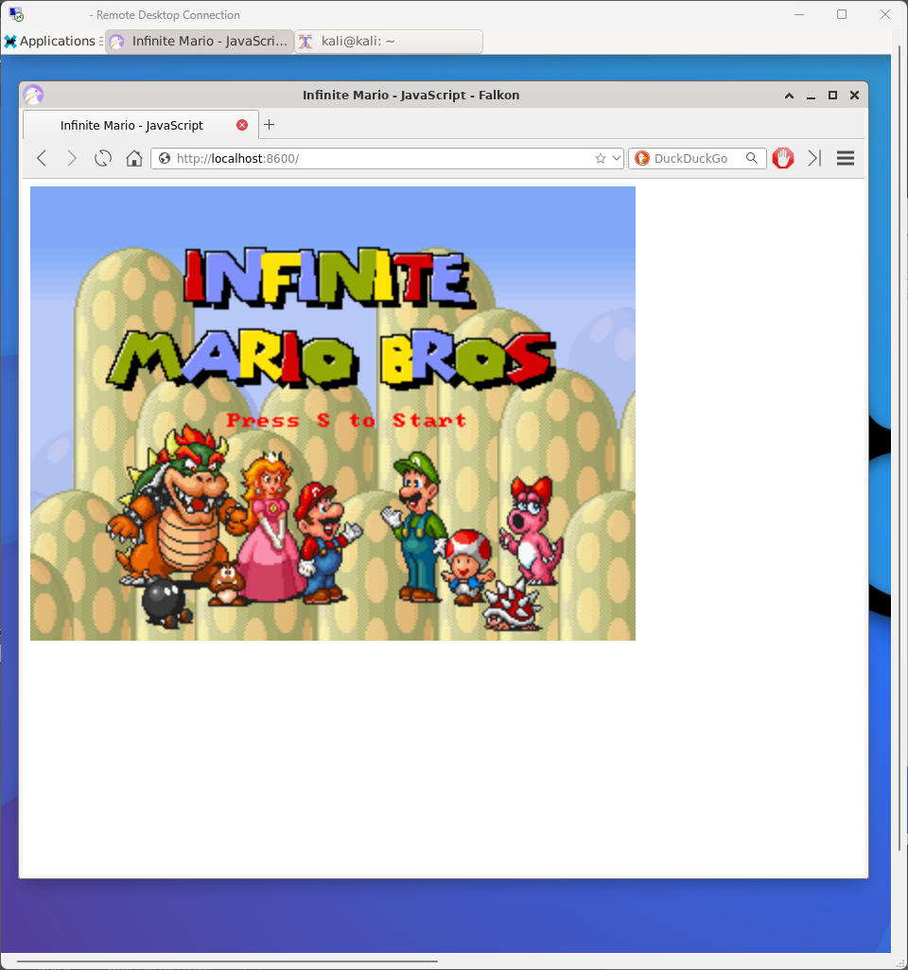](http://localhost:8600/)

🎉 Congratulations 🎉

You have completed your lab AND stretch goals! 🚀